---------------------------------------------------------------------

-- LAB 14

--

-- Exercise 1

---------------------------------------------------------------------

USE TSQL;

GO

---------------------------------------------------------------------

-- Task 1

--

-- The IT department has provided you with T-SQL code to generate a view named Sales.CustGroups, which contains three pieces of information about customers: their IDs, the countries in which they are located, and the customer group in which they have been placed. Customers are placed into one of three predefined customers groups (A, B, or C).

--

-- Execute the provided T-SQL code.

CREATE VIEW Sales.CustGroups AS

SELECT

custid,

CHOOSE(custid % 3 + 1, N'A', N'B', N'C') AS custgroup,

country

FROM Sales.Customers;

GO

--

Commands completed successfully.

Completion time: 2024-08-19T12:17:57.9204591+02:00

-- Write a SELECT statement that will return the custid, custgroup, and country columns from the newly created Sales.CustGroups view.

--

Select sc.custid , sc.custgroup , sc.country

FROM Sales.CustGroups AS sc

-- Execute the written statement and compare the results that you got with the desired results shown in the file 52 - Lab Exercise 1 - Task 1_1 Result.txt.

custid custgroup country

------------------------------

1 B Germany

2 C Mexico

3 A Mexico

4 B UK

5 C Sweden

6 A Germany

7 B France

8 C Spain

9 A France

10 B Canada

11 C UK

12 A Argentina

13 B Mexico

14 C Switzerland

15 A Brazil

16 B UK

17 C Germany

18 A France

19 B UK

20 C Austria

21 A Brazil

22 B Spain

23 C France

24 A Sweden

25 B Germany

26 C France

27 A Italy

28 B Portugal

29 C Spain

30 A Spain

31 B Brazil

32 C USA

33 A Venezuela

34 B Brazil

35 C Venezuela

36 A USA

37 B Ireland

38 C UK

39 A Germany

40 B France

41 C France

42 A Canada

43 B USA

44 C Germany

45 A USA

46 B Venezuela

47 C Venezuela

48 A USA

49 B Italy

50 C Belgium

51 A Canada

52 B Germany

53 C UK

54 A Argentina

55 B USA

56 C Germany

57 A France

58 B Mexico

59 C Austria

60 A Portugal

61 B Brazil

62 C Brazil

63 A Germany

64 B Argentina

65 C USA

66 A Italy

67 B Brazil

68 C Switzerland

69 A Spain

70 B Norway

71 C USA

72 A UK

73 B Denmark

74 C France

75 A USA

76 B Belgium

77 C USA

78 A USA

79 B Germany

80 C Mexico

81 A Brazil

82 B USA

83 C Denmark

84 A France

85 B France

86 C Germany

87 A Finland

88 B Brazil

89 C USA

90 A Finland

91 B Poland

-- Modify the SELECT statement. Begin by retrieving the column country. Then use the PIVOT operator to retrieve three columns based on the possible values of the custgroup column (values A, B, and C), showing the number of customers in each group.

Select [country] , [A] ,[B] ,[C]

From (SELECT

custid,

CHOOSE(custid % 3 + 1, N'A', N'B', N'C') AS custgroup,

country

FROM Sales.Customers

) as sel

PIVOT(COUNT(custid) FOR custgroup IN ([A],[B],[C]) ) AS pvt

Order By [country]

go

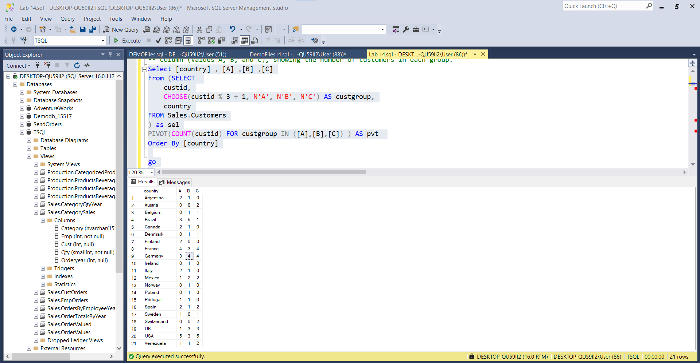

-- Execute the modified statement and compare the results that you got with the desired results shown in the file 53 - Lab Exercise 1 - Task 1_2 Result.txt.

country A B C

-------------------------------------

Argentina 2 1 0

Austria 0 0 2

Belgium 0 1 1

Brazil 3 5 1

Canada 2 1 0

Denmark 0 1 1

Finland 2 0 0

France 4 3 4

Germany 3 4 4

Ireland 0 1 0

Italy 2 1 0

Mexico 1 2 2

Norway 0 1 0

Poland 0 1 0

Portugal 1 1 0

Spain 2 1 2

Sweden 1 0 1

Switzerland 0 0 2

UK 1 3 3

USA 5 3 5

Venezuela 1 1 2

---------------------------------------------------------------------

---------------------------------------------------------------------

-- Task 2

--

-- The IT department has provided T-SQL code to add two new columns—city and contactname—to the Sales.CustGroups view. Execute the provided T-SQL code.

ALTER VIEW Sales.CustGroups AS

SELECT

custid,

CHOOSE(custid % 3 + 1, N'A', N'B', N'C') AS custgroup,

country,

city,

contactname

FROM Sales.Customers;

GO

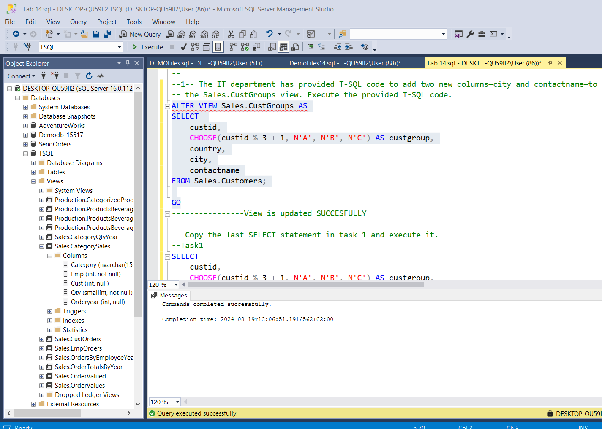

-- Copy the last SELECT statement in task 1 and execute it.

--

--Task1

SELECT

custid,

CHOOSE(custid % 3 + 1, N'A', N'B', N'C') AS custgroup,

country

FROM Sales.Customers

--Task2

SELECT

custid,

CHOOSE(custid % 3 + 1, N'A', N'B', N'C') AS custgroup,

country,

city,

contactname

FROM Sales.Customers

-- Is this result the same as the result from the query in task 1? Is the number of rows retrieved the same?

**Query in ‘TASK1’ and Query in ‘TASK2’ execute the same number of rows, 91 rows

-- To better understand the reason for the different results, modify the copied SELECT statement to include the new city and contactname columns.

**That’s the difference ,the new attributes added

-- Execute the modified statement and compare the results that you got with the desired results shown in the file 54 - Lab Exercise 1 - Task 2 Result.txt.

--TASK1--

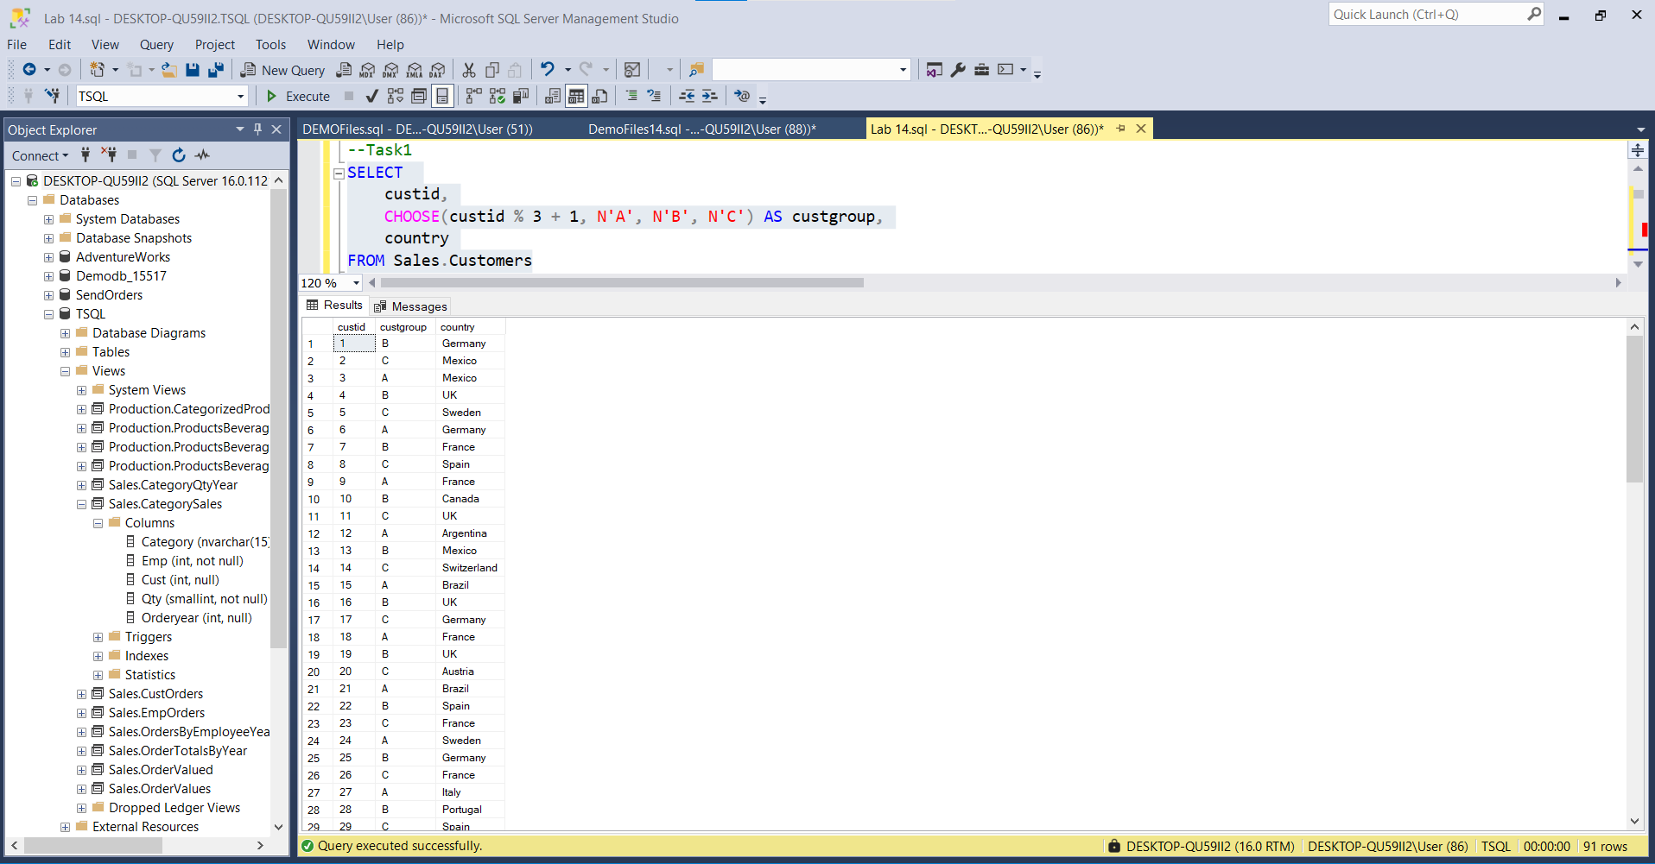

--TASK2--

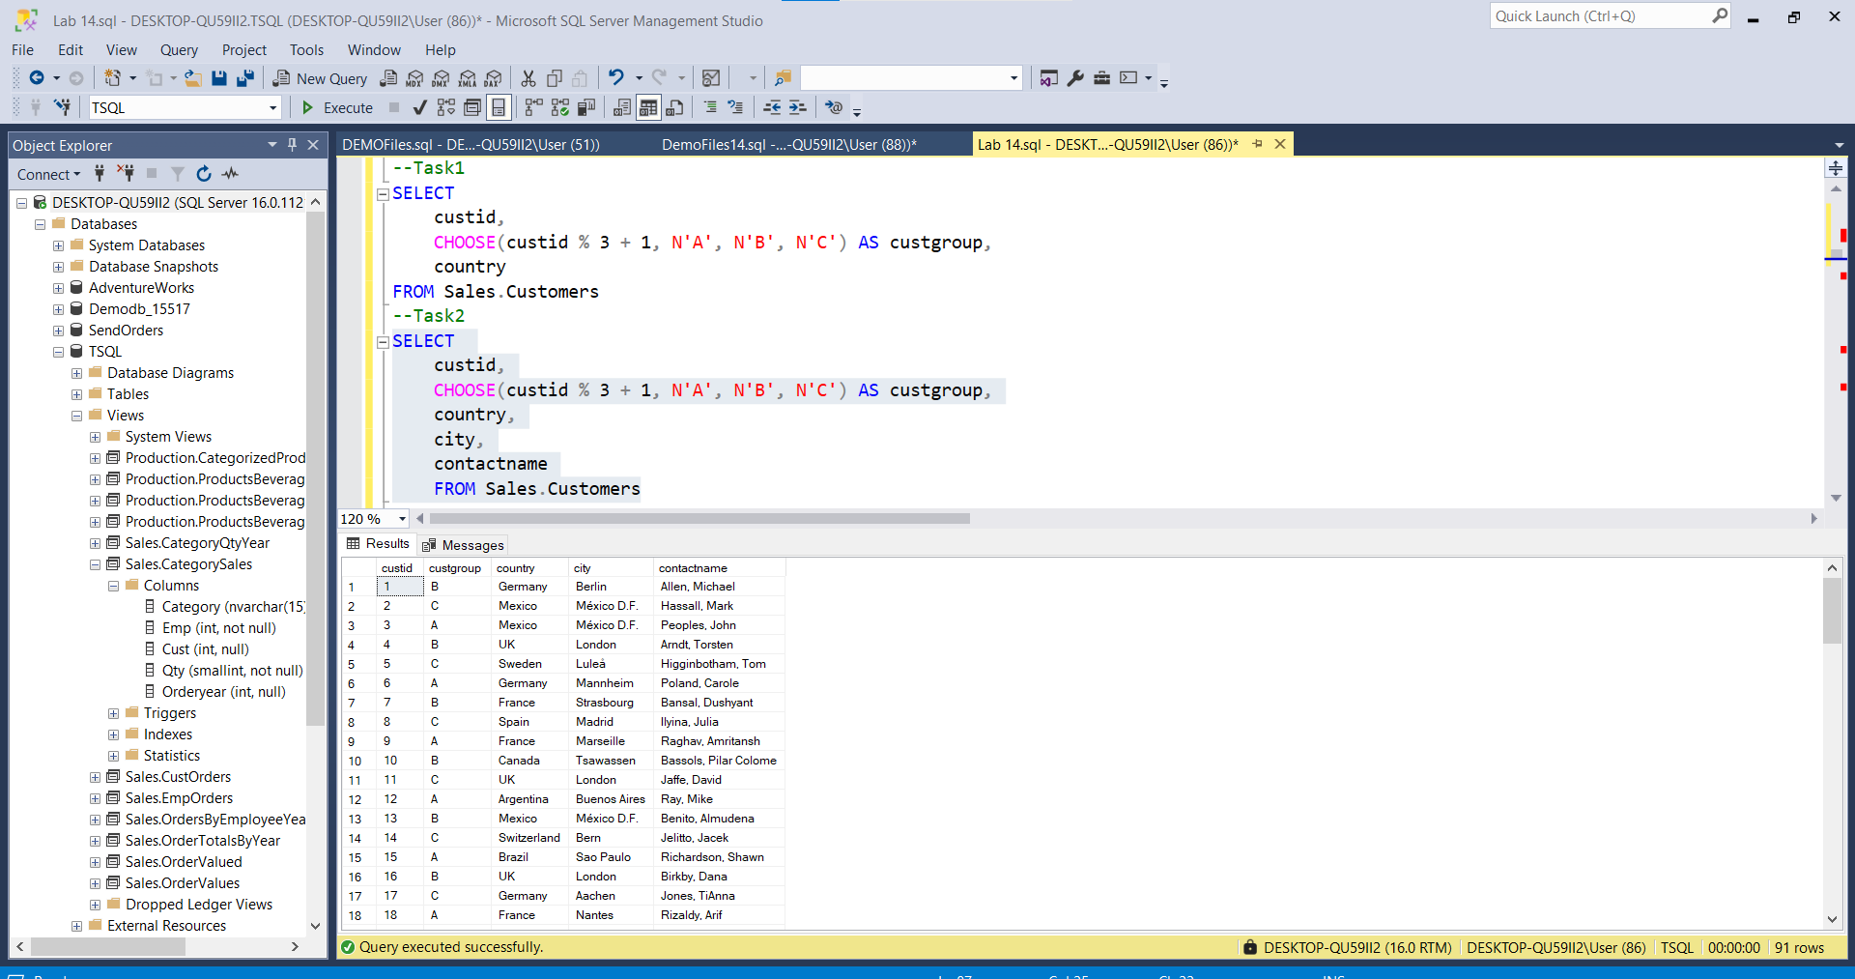

-- Notice that this query returned the same number of rows as the previous SELECT statement. Why did you get the same result with and without specifying the grouping columns for the PIVOT operator?

---------------------------------------------------------------------

---------------------------------------------------------------------

-- Task 3

--

-- Define a CTE named PivotCustGroups based on a query that retrieves the custid, country, and custgroup columns from the Sales.CustGroups view. Write a SELECT statement against the CTE, using a PIVOT operator to retrieve the same result as in task 1.

--1--

WITH CTE_PivotCustGroups

as

(Select [custid] , [A],[B],[C]

From (SELECT

custid,

CHOOSE(custid % 3 + 1, N'A', N'B', N'C') AS custgroup,

country,

city,

contactname

FROM Sales.Customers) AS c

PIVOT (COUNT(country) FOR custgroup IN ([A],[B],[C])) AS pvt

)

Select * From CTE_PivotCustGroups

--2--

WITH CTE_PivotCustGroups

as

(Select [country] , [A] ,[B] ,[C]

From (SELECT custid,CHOOSE(custid % 3 + 1, N'A', N'B', N'C') AS custgroup,country,city,

contactname

FROM Sales.Customers

) as sel

PIVOT(COUNT(custid) FOR custgroup IN ([A],[B],[C]) ) AS pvt

)

Select * From CTE_PivotCustGroups

GO -- Execute the written T-SQL code and compare the results that you got with the desired results shown in the file 55 - Lab Exercise 1 - Task 3 Result.txt.

--1--

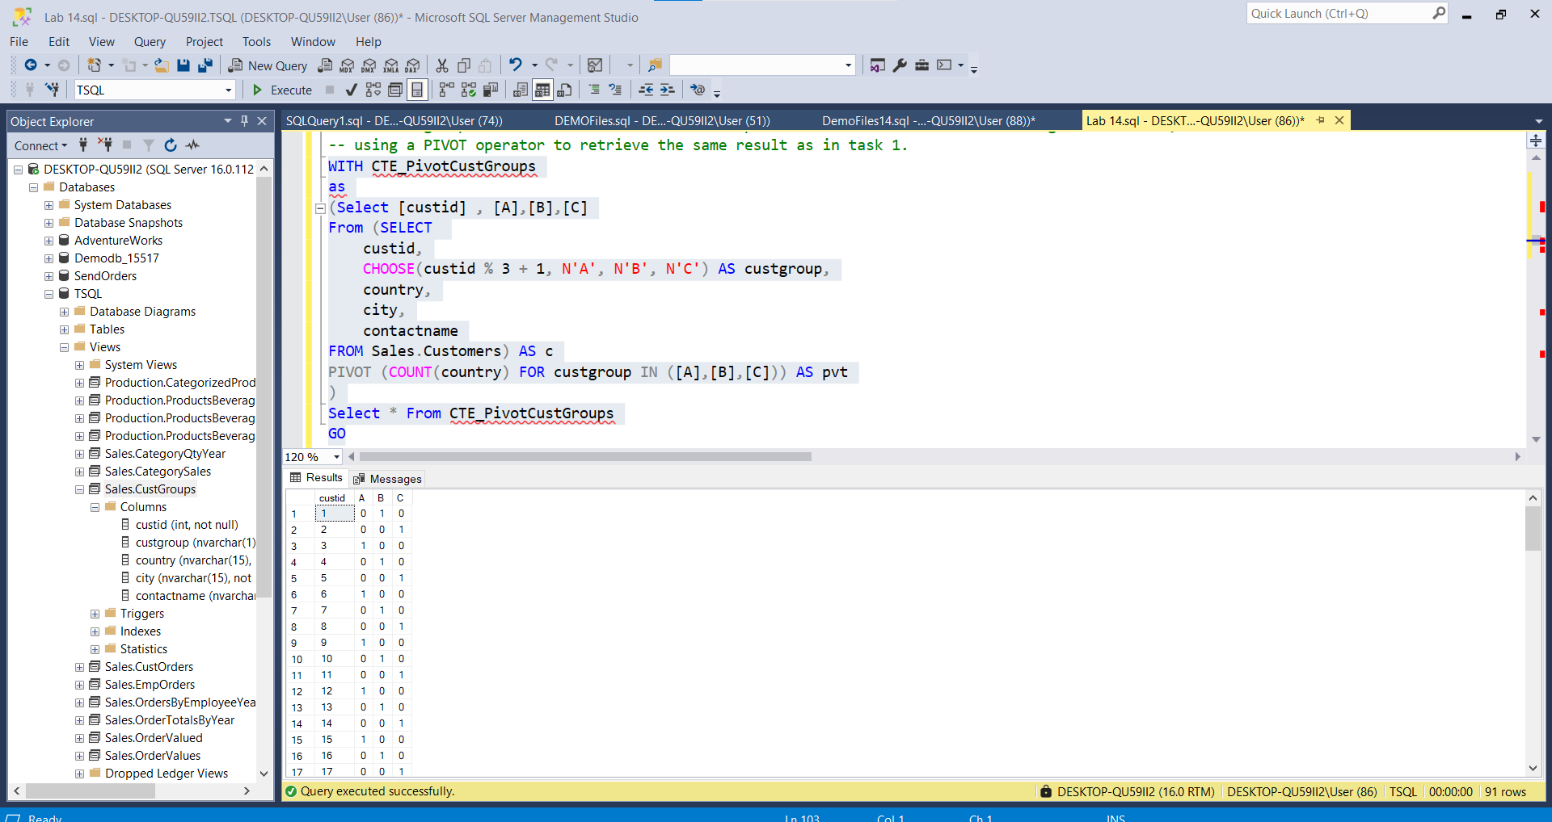

--2--

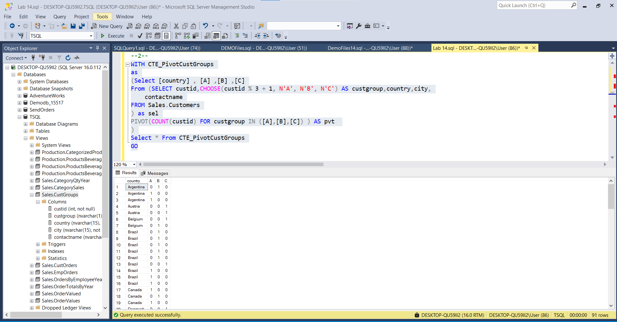

-- Is this result the same as the one returned by the last query in task 1? Can you explain why? **Yes , Because we filter by PIVOT the same attributes .

--

-- Why do you think it is beneficial to use the CTE when using the PIVOT operator?

---------------------------------------------------------------------

---------------------------------------------------------------------

-- Task 4

--

-- For each customer, write a SELECT statement to retrieve the total sales amount for each product category. Display each product category as a separate column. Here is how to accomplish this task:

-- Create a CTE named SalesByCategory to retrieve the custid column from the Sales.Orders table as a calculated column based on the qty and unitprice columns and the categoryname column from the table Production.Categories. Filter the result to include only orders in the year 2008.

-- You will need to JOIN tables Sales.Orders, Sales.OrderDetails, Production.Products and Production.Categories.

-- Write a SELECT statement against the CTE that returns a row for each customer (custid) and a column for each product category, with the total sales amount for the current customer and product category.

-- Display the following product categories: Beverages, Condiments, Confections, [Dairy Products], [Grains/Cereals], [Meat/Poultry], Produce, and Seafood..

WITH CTE_SalesByCategory

AS

(

Select [CustomerID], [Beverages],[Condiments],[Confections],[Dairy_Products],[Grains/Cereals],[Meat/Poultry],[Produce],[Seafood]

From(

Select sales.CustomerID , SUM(sales.totalSalesOrder) as TotalSales ,sales.CategoryId ,sales.CategoryName

From(

Select o.custid as CustomerID ,o.orderid, SUM((od.unitprice*od.qty)*(1-od.discount)) as totalSalesOrder , pc.categoryid CategoryId,pc.categoryname CategoryName

From Sales.Orders o inner join Sales.OrderDetails od ON o.orderid = od.orderid

inner join Production.Products pp ON od.productid = pp.productid

inner join Production.Categories pc ON pp.categoryid = pc.categoryid

Where year(o.orderdate) = 2008

Group By o.custid,o.orderid , pc.categoryid , pc.categoryname

--Order By c.custid

) as sales

Group By sales.CustomerID,sales.CategoryId ,sales.CategoryName ) as m

PIVOT (SUM(sales.totalSalesOrder) FOR categoryname IN ([Beverages],[Condiments],[Confections],[Dairy_Products]

,[Grains/Cereals],[Meat/Poultry],[Produce],[Seafood])) as pvt

--Order By CustomerID

)

Select * From CTE_SalesByCategory

-- Execute the complete T-SQL code (the CTE and the SELECT statement).

--

-- Observe and compare the results that you got with the desired results shown in the file 56 - Lab Exercise 1 - Task 4 Result.txt.

---------------------------------------------------------------------

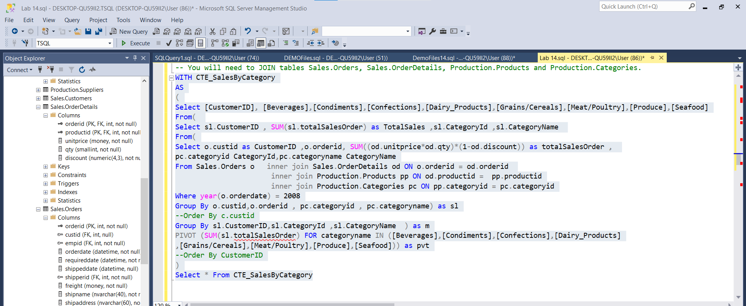

---------------------------------------------------------------------

-- LAB 14

--

-- Exercise 2

---------------------------------------------------------------------

USE TSQL;

GO

---------------------------------------------------------------------

-- Task 1

--

-- Execute the provided T-SQL code to generate the Sales.PivotCustGroups view:

--

CREATE VIEW Sales.PivotCustGroups AS

(

SELECT

custid,

country,

custgroup

FROM Sales.CustGroups

)

GO

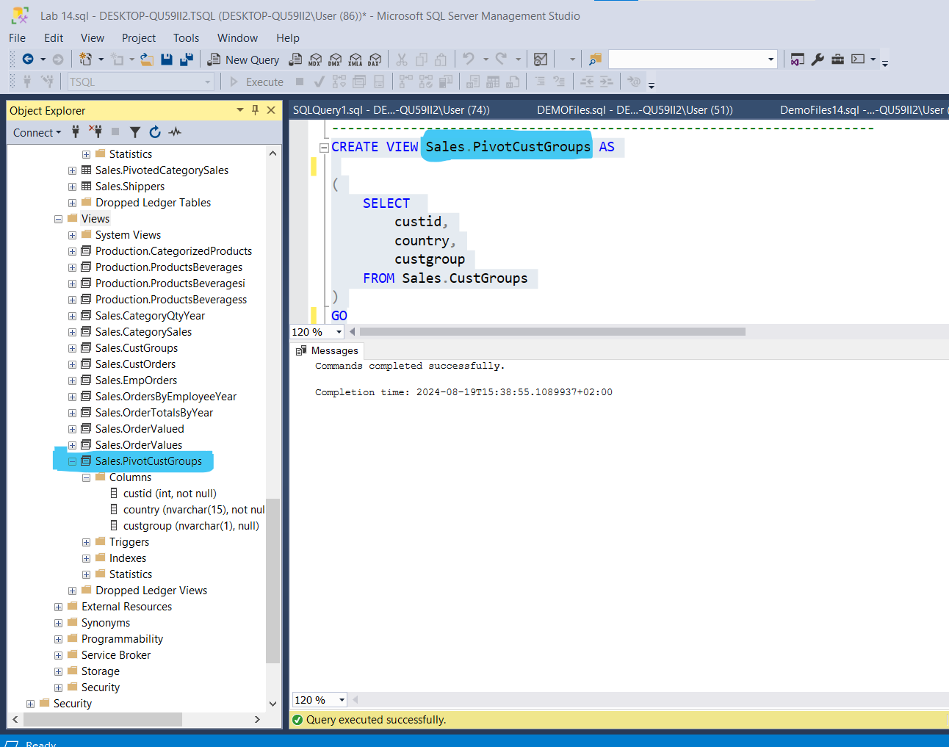

-- Write a SELECT statement to retrieve the country, A, B, and C columns from the Sales.PivotCustGroups view.

--

SELECT country,p.A,p.B,p.C

FROM Sales.PivotCustGroups pp

PIVOT (COUNT(custid) FOR custgroup IN (A, B, C)) AS p

GO

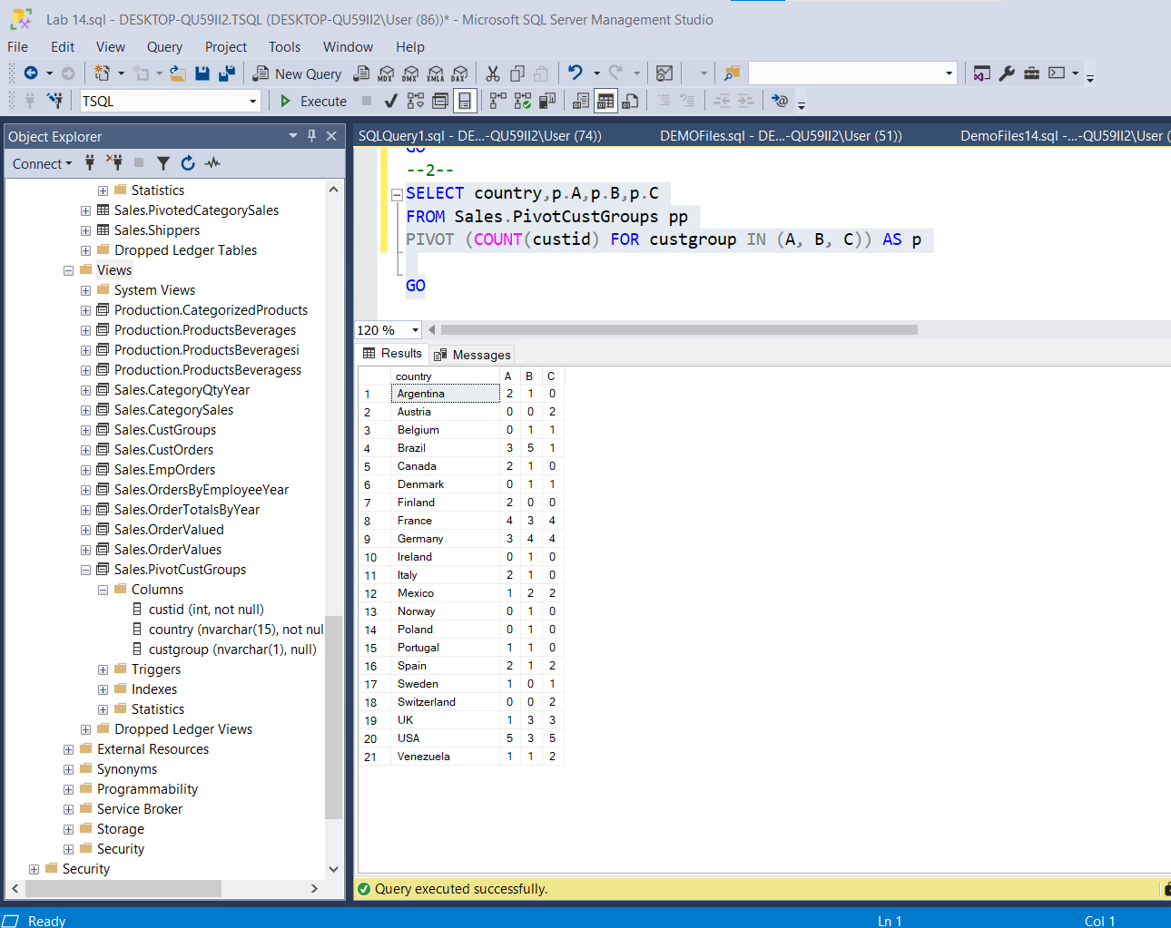

-- Execute the written statement and compare the results that you got with the desired results shown in the file 62 - Lab Exercise 2 - Task 1 Result.txt.

---------------------------------------------------------------------

---------------------------------------------------------------------

-- Task 2

--

-- Write a SELECT statement against the Sales.PivotCustGroups view that returns the following:

-- A row for each country and customer group.

-- The column country.

-- Two new columns—custgroup and numberofcustomers. The custgroup column should hold the names of the source columns A, B, and C as character strings, and the numberofcustomers column should hold their values (i.e., number of customers).

Select pcg.custgroup,count(pcg.custid) as numberOfCustomers

From Sales.PivotCustGroups pcg

group by pcg.custgroup

-- Execute the T-SQL code and compare the results that you got with the recommended result shown in the file 63 - Lab Exercise 2 - Task 2 Result.txt.

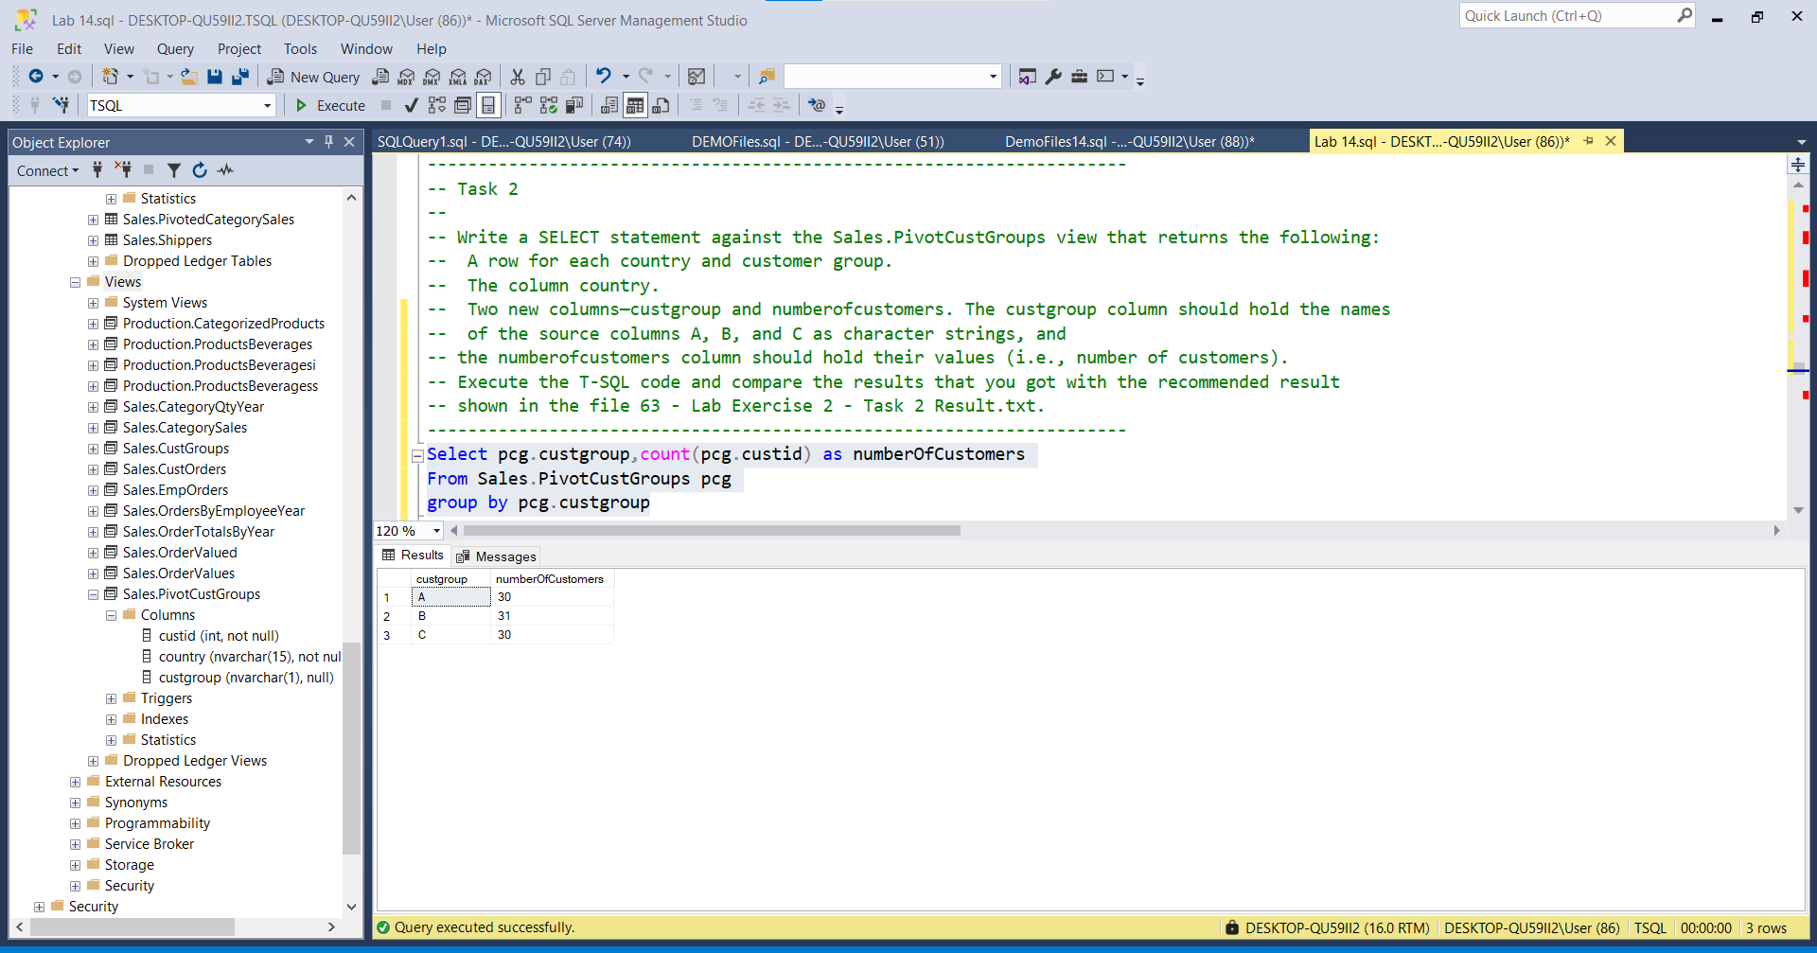

---------------------------------------------------------------------

---------------------------------------------------------------------

-- Task 3

--

-- Remove the created views by executing the provided T-SQL code. Execute this code exactly as written inside a query window.

---------------------------------------------------------------------

DROP VIEW Sales.CustGroups;

DROP VIEW Sales.PivotCustGroups; 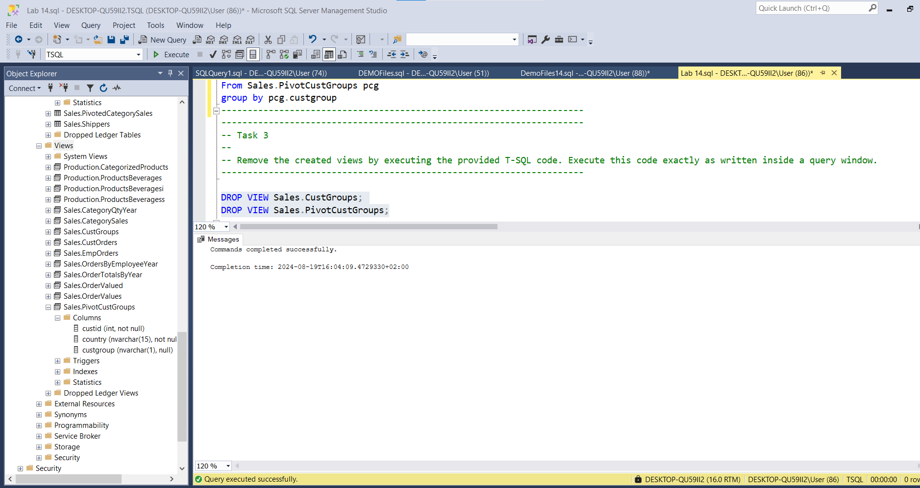

---------------------------------------------------------------------

---------------------------------------------------------------------

-- LAB 14

--

-- Exercise 3

---------------------------------------------------------------------

USE TSQL;

GO

---------------------------------------------------------------------

-- Task 1

--

-- Write a SELECT statement against the Sales.Customers table and retrieve the country column, the city column, and a calculated column noofcustomers as a count of customers. Retrieve multiple grouping sets based on the country and city columns, the country column, the city column, and a column with an empty grouping set.

Select sc.country , sc.city ,noofcustomers = COUNT(sc.custid)

From Sales.Customers sc

GROUP BY --sc.country , sc.city

GROUPING SETS ((sc.country) , (sc.city),())

order by sc.country , sc.city

-- Execute the written statement and compare the results that you got with the recommended result shown in the file 72 - Lab Exercise 3 - Task 1 Result.txt.

country city noofcustomers

----------------------------------

NULL NULL 91

NULL Aachen 1

NULL Albuquerque 1

NULL Anchorage 1

NULL Århus 1

NULL Barcelona 1

NULL Barquisimeto 1

NULL Bergamo 1

NULL Berlin 1

NULL Bern 1

NULL Boise 1

NULL Bräcke 1

NULL Brandenburg 1

NULL Bruxelles 1

NULL Buenos Aires 3

NULL Butte 1

NULL Campinas 1

NULL Caracas 1

NULL Charleroi 1

NULL Cork 1

NULL Cowes 1

NULL Cunewalde 1

NULL Elgin 1

NULL Eugene 1

NULL Frankfurt a.M. 1

NULL Genève 1

NULL Graz 1

NULL Helsinki 1

NULL I. de Margarita 1

NULL Kirkland 1

NULL Kobenhavn 1

NULL Köln 1

NULL Lander 1

NULL Leipzig 1

NULL Lille 1

NULL Lisboa 2

NULL London 6

NULL Luleå 1

NULL Lyon 1

NULL Madrid 3

NULL Mannheim 1

NULL Marseille 1

NULL México D.F. 5

NULL Montréal 1

NULL München 1

NULL Münster 1

NULL Nantes 2

NULL Oulu 1

NULL Paris 2

NULL Portland 2

NULL Reggio Emilia 1

NULL Reims 1

NULL Resende 1

NULL Rio de Janeiro 3

NULL Salzburg 1

NULL San Cristóbal 1

NULL San Francisco 1

NULL Sao Paulo 4

NULL Seattle 1

NULL Sevilla 1

NULL Stavern 1

NULL Strasbourg 1

NULL Stuttgart 1

NULL Torino 1

NULL Toulouse 1

NULL Tsawassen 1

NULL Vancouver 1

NULL Versailles 1

NULL Walla Walla 1

NULL Warszawa 1

Argentina NULL 3

Austria NULL 2

Belgium NULL 2

Brazil NULL 9

Canada NULL 3

Denmark NULL 2

Finland NULL 2

France NULL 11

Germany NULL 11

Ireland NULL 1

Italy NULL 3

Mexico NULL 5

Norway NULL 1

Poland NULL 1

Portugal NULL 2

Spain NULL 5

Sweden NULL 2

Switzerland NULL 2

UK NULL 7

USA NULL 13

Venezuela NULL 4

---------------------------------------------------------------------

---------------------------------------------------------------------

-- Task 2

--

-- Write a SELECT statement against the view Sales.OrderValues and retrieve these columns:

-- Year of the orderdate column as orderyear

-- Month of the orderdate column as ordermonth

-- Day of the orderdate column as orderday

-- Total sales value using the val column as salesvalue

-- Return all possible grouping sets based on the orderyear, ordermonth, and orderday columns.

--

Select year(ov.orderdate) as orderyear , month(ov.orderdate) as ordermonth,

day(ov.orderdate) as orderday,Sum(ov.val) as salesValue

From Sales.OrderValues ov

Group by

Grouping Sets((year(ov.orderdate)),(month(ov.orderdate)),(day(ov.orderdate)),())

-- Execute the written statement and compare the results that you got with the recommended result shown in the file 73 - Lab Exercise 3 - Task 2 Result.txt. Notice the total number of rows in your results.

Orderyear ordermonth orderday salesValue

---------------------------------------------------------------

NULL NULL 1 46223.36

NULL NULL 2 46666.70

NULL NULL 3 37221.00

NULL NULL 4 40755.33

NULL NULL 5 43613.44

NULL NULL 6 52469.64

NULL NULL 7 19065.33

NULL NULL 8 31875.51

NULL NULL 9 31551.99

NULL NULL 10 40746.09

NULL NULL 11 36010.84

NULL NULL 12 32872.70

NULL NULL 13 48457.48

NULL NULL 14 33587.00

NULL NULL 15 33012.59

NULL NULL 16 60458.89

NULL NULL 17 53112.08

NULL NULL 18 43120.92

NULL NULL 19 69819.16

NULL NULL 20 33887.53

NULL NULL 21 33550.98

NULL NULL 22 54212.19

NULL NULL 23 52824.87

NULL NULL 24 27618.94

NULL NULL 25 27412.26

NULL NULL 26 44812.97

NULL NULL 27 58640.16

NULL NULL 28 31817.69

NULL NULL 29 28459.97

NULL NULL 30 49360.40

NULL NULL 31 22555.21

NULL NULL NULL 1265793.22

NULL 1 NULL 155480.20

NULL 2 NULL 137898.93

NULL 3 NULL 143401.41

NULL 4 NULL 176831.65

NULL 5 NULL 72114.94

NULL 6 NULL 36362.82

NULL 7 NULL 78882.76

NULL 8 NULL 72772.96

NULL 9 NULL 82010.67

NULL 10 NULL 104264.96

NULL 11 NULL 89133.85

NULL 12 NULL 116638.07

2006 NULL NULL 208083.99

2007 NULL NULL 617085.30

2008 NULL NULL 440623.93

---------------------------------------------------------------------

---------------------------------------------------------------------

-- Task 3

--

-- Copy the previous query and modify it to use the ROLLUP subclause instead of the CUBE subclause.

Select year(ov.orderdate) as orderyear , month(ov.orderdate) as ordermonth,

day(ov.orderdate) as orderday,Sum(ov.val) as salesValue

From Sales.OrderValues ov

Group by rollup

((year(ov.orderdate)),(month(ov.orderdate)),(day(ov.orderdate)))

-- Execute the modified query and compare the results that you got with the recommended result shown in the file 74 - Lab Exercise 3 - Task 3 Result.txt. Notice the number of rows in your results.

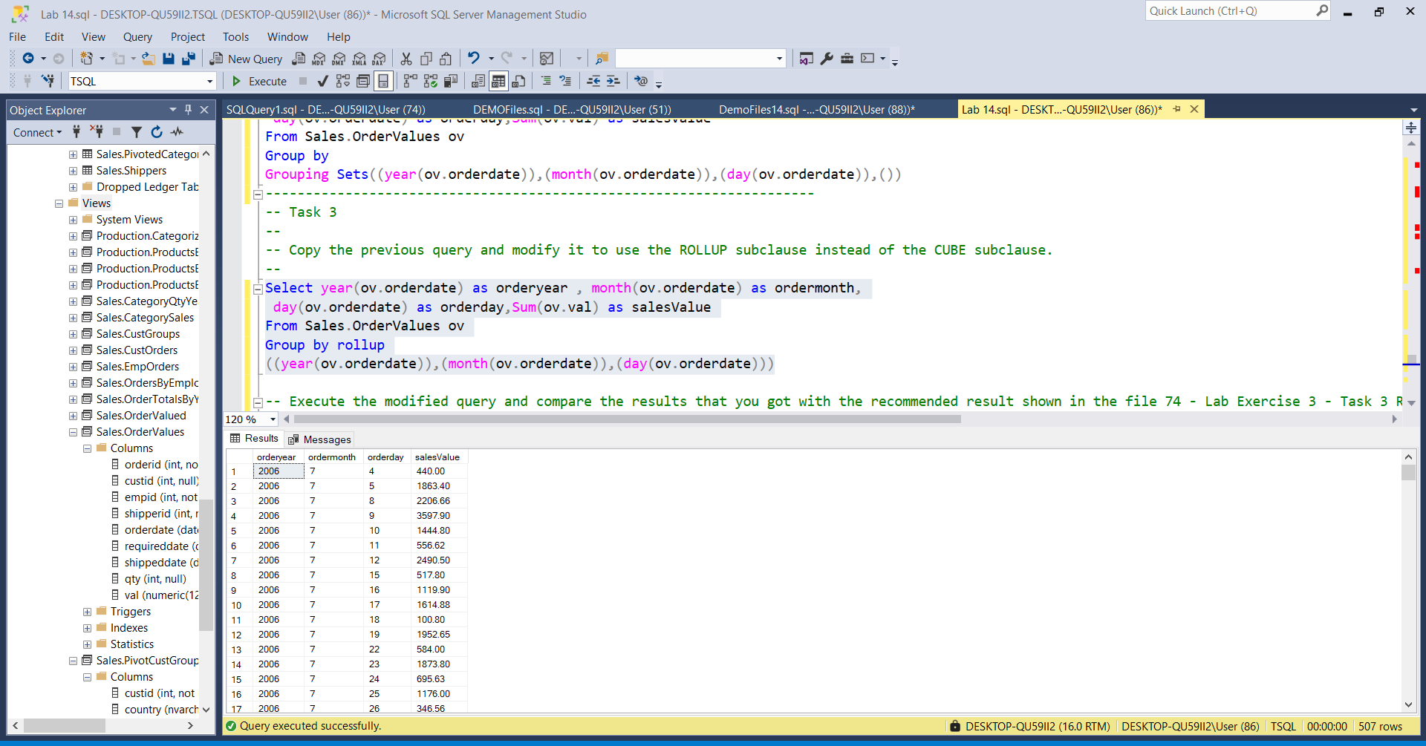

oyear omonth oday salesValue

--------------------------------------

2006 7 4 440.00

2006 7 5 1863.40

2006 7 8 2206.66

2006 7 9 3597.90

2006 7 10 1444.80

2006 7 11 556.62

2006 7 12 2490.50

2006 7 15 517.80

2006 7 16 1119.90

2006 7 17 1614.88

2006 7 18 100.80

2006 7 19 1952.65

2006 7 22 584.00

2006 7 23 1873.80

2006 7 24 695.63

2006 7 25 1176.00

2006 7 26 346.56

2006 7 29 3536.60

2006 7 30 1101.20

2006 7 31 642.20

2006 7 NULL 27861.90

2006 8 1 1424.00

2006 8 2 1456.00

2006 8 5 2037.28

2006 8 6 538.60

2006 8 7 291.84

2006 8 8 420.00

2006 8 9 1200.80

2006 8 12 1488.80

2006 8 13 351.00

2006 8 14 699.70

2006 8 15 155.40

2006 8 16 1414.80

2006 8 19 1170.38

2006 8 20 1743.36

2006 8 21 3016.00

2006 8 22 819.00

2006 8 23 80.10

2006 8 26 479.40

2006 8 27 2666.52

2006 8 28 1296.00

2006 8 29 848.70

2006 8 30 1887.60

2006 8 NULL 25485.28

2006 9 2 121.60

2006 9 3 1050.60

2006 9 4 1420.00

2006 9 5 2645.00

2006 9 6 349.50

2006 9 9 1363.00

2006 9 10 2708.80

2006 9 11 1117.80

2006 9 12 954.40

2006 9 13 3741.30

2006 9 16 498.50

2006 9 17 424.00

2006 9 18 88.80

2006 9 19 1762.00

2006 9 20 604.80

2006 9 23 1614.80

2006 9 24 182.40

2006 9 25 2094.30

2006 9 26 516.80

2006 9 27 2835.00

2006 9 30 288.00

2006 9 NULL 26381.40

2006 10 1 240.40

2006 10 2 1191.20

2006 10 3 660.00

2006 10 4 112.00

2006 10 7 164.40

2006 10 8 5275.72

2006 10 9 1497.00

2006 10 10 982.00

2006 10 11 1810.00

2006 10 14 1168.00

2006 10 15 4578.43

2006 10 16 1737.50

2006 10 17 1786.88

2006 10 18 877.20

2006 10 21 144.80

2006 10 22 2036.16

2006 10 23 285.12

2006 10 24 2467.00

2006 10 25 934.50

2006 10 28 3354.00

2006 10 29 2788.78

2006 10 30 1840.64

2006 10 31 1584.00

2006 10 NULL 37515.73

2006 11 1 2296.00

2006 11 4 2924.80

2006 11 5 1618.88

2006 11 6 814.42

2006 11 7 363.60

2006 11 8 141.60

2006 11 11 6040.79

2006 11 12 136.30

2006 11 13 8593.28

2006 11 14 568.80

2006 11 15 480.00

2006 11 18 1106.40

2006 11 19 1167.68

2006 11 20 429.40

2006 11 21 3471.68

2006 11 22 9436.44

2006 11 25 1549.60

2006 11 26 1397.20

2006 11 27 403.20

2006 11 28 970.20

2006 11 29 1689.78

2006 11 NULL 45600.05

2006 12 2 2390.40

2006 12 3 1190.56

2006 12 4 9210.90

2006 12 5 1825.40

2006 12 6 338.00

2006 12 9 1262.60

2006 12 10 103.20

2006 12 11 863.28

2006 12 12 1425.82

2006 12 13 2900.00

2006 12 16 3121.40

2006 12 17 691.20

2006 12 18 1224.40

2006 12 19 1228.80

2006 12 20 1832.80

2006 12 23 2177.28

2006 12 24 1440.00

2006 12 25 2998.95

2006 12 26 2122.92

2006 12 27 2620.52

2006 12 30 2505.60

2006 12 31 1765.60

2006 12 NULL 45239.63

2006 NULL NULL 208083.99

2007 1 1 6931.60

2007 1 2 2713.50

2007 1 3 2446.27

2007 1 6 400.00

2007 1 7 3024.78

2007 1 8 1622.40

2007 1 9 319.20

2007 1 10 1768.80

2007 1 13 334.80

2007 1 14 2348.03

2007 1 15 102.40

2007 1 16 11908.40

2007 1 17 1814.80

2007 1 20 2097.60

2007 1 21 2902.11

2007 1 22 49.80

2007 1 23 10214.56

2007 1 24 360.00

2007 1 27 989.20

2007 1 28 192.00

2007 1 29 1441.38

2007 1 30 6791.45

2007 1 31 485.00

2007 1 NULL 61258.08

2007 2 3 1172.32

2007 2 4 631.60

2007 2 5 2387.52

2007 2 6 454.00

2007 2 7 1078.00

2007 2 10 6679.14

2007 2 11 1792.00

2007 2 12 1549.14

2007 2 13 174.90

2007 2 14 1160.64

2007 2 17 443.40

2007 2 18 1838.20

2007 2 19 4274.78

2007 2 20 2018.50

2007 2 21 738.90

2007 2 24 2684.00

2007 2 25 2141.60

2007 2 26 3891.00

2007 2 27 1659.20

2007 2 28 1714.80

2007 2 NULL 38483.64

2007 3 3 156.00

2007 3 4 2322.58

2007 3 5 2518.00

2007 3 6 451.20

2007 3 7 717.60

2007 3 10 956.68

2007 3 11 3148.80

2007 3 12 1036.80

2007 3 13 1479.50

2007 3 14 1505.18

2007 3 17 738.48

2007 3 18 471.20

2007 3 19 10495.60

2007 3 20 2228.00

2007 3 21 147.00

2007 3 24 1055.00

2007 3 25 1584.00

2007 3 26 2161.70

2007 3 27 1512.00

2007 3 28 439.20

2007 3 31 3422.71

2007 3 NULL 38547.23

2007 4 1 851.20

2007 4 2 1520.40

2007 4 3 278.00

2007 4 4 1570.60

2007 4 7 575.00

2007 4 8 1412.00

2007 4 9 672.26

2007 4 10 816.30

2007 4 11 3437.00

2007 4 14 147.90

2007 4 15 1164.86

2007 4 16 240.00

2007 4 17 136.80

2007 4 18 7257.54

2007 4 21 525.30

2007 4 22 10565.45

2007 4 23 9921.30

2007 4 24 2733.05

2007 4 25 4150.05

2007 4 28 2314.20

2007 4 29 425.50

2007 4 30 2318.24

2007 4 NULL 53032.95

2007 5 1 5636.96

2007 5 2 818.40

2007 5 5 2654.40

2007 5 6 392.20

2007 5 7 946.00

2007 5 8 4290.00

2007 5 9 796.35

2007 5 12 2687.90

2007 5 13 1940.85

2007 5 14 3468.80

2007 5 15 139.80

2007 5 16 355.50

2007 5 19 12138.22

2007 5 20 469.11

2007 5 21 1921.70

2007 5 22 210.00

2007 5 23 4604.80

2007 5 26 240.10

2007 5 27 3554.28

2007 5 28 2360.60

2007 5 29 880.50

2007 5 30 3274.83

2007 5 NULL 53781.30

2007 6 2 2944.40

2007 6 3 1987.70

2007 6 4 2142.90

2007 6 5 520.41

2007 6 6 3916.93

2007 6 9 488.70

2007 6 10 2199.05

2007 6 11 639.90

2007 6 12 4280.00

2007 6 13 155.00

2007 6 16 890.00

2007 6 17 3015.84

2007 6 18 1501.09

2007 6 19 2846.30

2007 6 20 2147.40

2007 6 23 1407.45

2007 6 24 477.00

2007 6 25 317.75

2007 6 26 1323.75

2007 6 27 330.00

2007 6 30 2831.25

2007 6 NULL 36362.82

2007 7 1 142.50

2007 7 2 831.18

2007 7 3 3120.00

2007 7 4 72.00

2007 7 7 1913.50

2007 7 8 516.47

2007 7 9 2559.90

2007 7 10 4725.00

2007 7 11 1898.96

2007 7 14 2388.50

2007 7 15 493.00

2007 7 16 2764.80

2007 7 17 48.75

2007 7 18 1713.85

2007 7 21 4109.70

2007 7 22 7605.80

2007 7 23 1064.00

2007 7 24 424.00

2007 7 25 1107.25

2007 7 28 6375.00

2007 7 29 817.20

2007 7 30 120.00

2007 7 31 6209.50

2007 7 NULL 51020.86

2007 8 1 2697.50

2007 8 4 1260.00

2007 8 5 816.00

2007 8 6 560.00

2007 8 7 2730.19

2007 8 8 479.75

2007 8 11 2689.35

2007 8 12 3225.05

2007 8 13 903.60

2007 8 14 644.80

2007 8 15 10496.09

2007 8 18 1326.23

2007 8 19 3391.44

2007 8 20 3220.05

2007 8 21 708.75

2007 8 22 2750.00

2007 8 25 2186.30

2007 8 26 1535.00

2007 8 27 2082.00

2007 8 28 1806.38

2007 8 29 1779.20

2007 8 NULL 47287.68

2007 9 1 716.64

2007 9 2 1684.98

2007 9 3 154.40

2007 9 4 4975.82

2007 9 5 5691.62

2007 9 8 1701.00

2007 9 9 687.60

2007 9 10 3218.79

2007 9 11 1295.00

2007 9 12 6203.74

2007 9 15 1195.28

2007 9 16 2301.75

2007 9 17 4735.35

2007 9 18 457.35

2007 9 19 1423.00

2007 9 22 1348.22

2007 9 23 5916.50

2007 9 24 1261.88

2007 9 25 1662.90

2007 9 26 1831.00

2007 9 29 801.10

2007 9 30 6365.35

2007 9 NULL 55629.27

2007 10 1 3633.10

2007 10 2 862.50

2007 10 3 11042.80

2007 10 6 6896.20

2007 10 7 642.00

2007 10 8 1801.43

2007 10 9 3550.44

2007 10 10 1638.40

2007 10 13 3194.50

2007 10 14 3140.50

2007 10 15 378.00

2007 10 16 3534.00

2007 10 17 3604.40

2007 10 20 93.50

2007 10 21 5685.18

2007 10 22 5033.65

2007 10 23 1296.00

2007 10 24 1976.75

2007 10 27 4307.25

2007 10 28 550.00

2007 10 29 2493.88

2007 10 30 1106.95

2007 10 31 287.80

2007 10 NULL 66749.23

2007 11 3 2279.50

2007 11 4 3146.75

2007 11 5 484.26

2007 11 6 2250.50

2007 11 7 2957.35

2007 11 10 536.40

2007 11 11 1136.80

2007 11 12 292.35

2007 11 13 1416.00

2007 11 14 3346.00

2007 11 17 1055.20

2007 11 18 4529.80

2007 11 19 4224.55

2007 11 20 3276.00

2007 11 21 1590.56

2007 11 24 1883.48

2007 11 25 143.20

2007 11 26 1948.50

2007 11 27 5072.00

2007 11 28 1964.60

2007 11 NULL 43533.80

2007 12 1 2917.00

2007 12 2 4844.00

2007 12 3 2902.00

2007 12 4 1515.60

2007 12 5 2338.00

2007 12 8 3161.28

2007 12 9 236.25

2007 12 10 3947.22

2007 12 11 2899.15

2007 12 12 228.00

2007 12 15 6859.28

2007 12 16 2151.50

2007 12 17 988.38

2007 12 18 3318.00

2007 12 19 4153.84

2007 12 22 5141.00

2007 12 23 2229.61

2007 12 24 2663.86

2007 12 25 2761.36

2007 12 26 3469.04

2007 12 29 5969.66

2007 12 30 6246.41

2007 12 31 458.00

2007 12 NULL 71398.44

2007 NULL NULL 617085.30

2008 1 1 1738.00

2008 1 2 2544.80

2008 1 5 2430.85

2008 1 6 19399.30

2008 1 7 2450.00

2008 1 8 915.90

2008 1 9 4107.56

2008 1 12 1573.00

2008 1 13 4670.00

2008 1 14 3159.51

2008 1 15 3185.44

2008 1 16 5770.00

2008 1 19 2977.13

2008 1 20 5556.00

2008 1 21 4706.70

2008 1 22 6043.92

2008 1 23 2528.32

2008 1 26 5587.00

2008 1 27 5819.39

2008 1 28 2708.21

2008 1 29 2246.69

2008 1 30 4104.40

2008 1 NULL 94222.12

2008 2 2 17110.65

2008 2 3 1194.60

2008 2 4 3710.60

2008 2 5 4037.69

2008 2 6 1356.35

2008 2 9 2872.13

2008 2 10 3650.30

2008 2 11 1042.64

2008 2 12 2623.07

2008 2 13 3197.50

2008 2 16 12845.10

2008 2 17 2458.93

2008 2 18 14634.61

2008 2 19 11585.74

2008 2 20 186.15

2008 2 23 1797.93

2008 2 24 3198.30

2008 2 25 536.00

2008 2 26 9613.30

2008 2 27 1763.70

2008 2 NULL 99415.29

2008 3 2 2936.19

2008 3 3 3817.30

2008 3 4 2825.25

2008 3 5 2112.25

2008 3 6 5763.93

2008 3 9 1575.50

2008 3 10 4014.18

2008 3 11 5642.75

2008 3 12 2677.83

2008 3 13 7004.25

2008 3 16 5481.21

2008 3 17 2410.94

2008 3 18 2675.45

2008 3 19 5027.05

2008 3 20 3998.96

2008 3 23 2426.40

2008 3 24 2500.11

2008 3 25 2068.50

2008 3 26 8349.70

2008 3 27 17792.90

2008 3 30 6053.13

2008 3 31 7700.40

2008 3 NULL 104854.18

2008 4 1 11549.89

2008 4 2 2696.50

2008 4 3 3768.95

2008 4 6 5809.85

2008 4 7 1211.07

2008 4 8 7931.30

2008 4 9 4764.80

2008 4 10 1357.03

2008 4 13 8401.00

2008 4 14 9840.64

2008 4 15 3266.81

2008 4 16 4324.53

2008 4 17 27143.85

2008 4 20 3985.90

2008 4 21 3882.60

2008 4 22 2588.75

2008 4 23 3386.90

2008 4 24 1616.48

2008 4 27 5233.00

2008 4 28 5772.50

2008 4 29 2741.00

2008 4 30 2525.35

2008 4 NULL 123798.70

2008 5 1 5448.57

2008 5 4 2473.93

2008 5 5 7632.48

2008 5 6 2778.66

2008 5 NULL 18333.64

2008 NULL NULL 440623.93

NULL NULL NULL 1265793.22

-- What is the difference between the ROLLUP and CUBE subclauses?

--using CUBE

Select year(ov.orderdate) as orderyear , month(ov.orderdate) as ordermonth,

day(ov.orderdate) as orderday,Sum(ov.val) as salesValue

From Sales.OrderValues ov

Group by cube

((year(ov.orderdate)),(month(ov.orderdate)),(day(ov.orderdate)))

Order By orderyear , ordermonth,orderday

oyear omonth oday salesValue

--------------------------------------

NULL NULL NULL 1265793.22

NULL NULL 1 46223.36

NULL NULL 2 46666.70

NULL NULL 3 37221.00

NULL NULL 4 40755.33

NULL NULL 5 43613.44

NULL NULL 6 52469.64

NULL NULL 7 19065.33

NULL NULL 8 31875.51

NULL NULL 9 31551.99

NULL NULL 10 40746.09

NULL NULL 11 36010.84

NULL NULL 12 32872.70

NULL NULL 13 48457.48

NULL NULL 14 33587.00

NULL NULL 15 33012.59

NULL NULL 16 60458.89

NULL NULL 17 53112.08

NULL NULL 18 43120.92

NULL NULL 19 69819.16

NULL NULL 20 33887.53

NULL NULL 21 33550.98

NULL NULL 22 54212.19

NULL NULL 23 52824.87

NULL NULL 24 27618.94

NULL NULL 25 27412.26

NULL NULL 26 44812.97

NULL NULL 27 58640.16

NULL NULL 28 31817.69

NULL NULL 29 28459.97

NULL NULL 30 49360.40

NULL NULL 31 22555.21

NULL 1 NULL 155480.20

NULL 1 1 8669.60

NULL 1 2 5258.30

NULL 1 3 2446.27

NULL 1 5 2430.85

NULL 1 6 19799.30

NULL 1 7 5474.78

NULL 1 8 2538.30

NULL 1 9 4426.76

NULL 1 10 1768.80

NULL 1 12 1573.00

NULL 1 13 5004.80

NULL 1 14 5507.54

NULL 1 15 3287.84

NULL 1 16 17678.40

NULL 1 17 1814.80

NULL 1 19 2977.13

NULL 1 20 7653.60

NULL 1 21 7608.81

NULL 1 22 6093.72

NULL 1 23 12742.88

NULL 1 24 360.00

NULL 1 26 5587.00

NULL 1 27 6808.59

NULL 1 28 2900.21

NULL 1 29 3688.07

NULL 1 30 10895.85

NULL 1 31 485.00

NULL 2 NULL 137898.93

NULL 2 2 17110.65

NULL 2 3 2366.92

NULL 2 4 4342.20

NULL 2 5 6425.21

NULL 2 6 1810.35

NULL 2 7 1078.00

NULL 2 9 2872.13

NULL 2 10 10329.44

NULL 2 11 2834.64

NULL 2 12 4172.21

NULL 2 13 3372.40

NULL 2 14 1160.64

NULL 2 16 12845.10

NULL 2 17 2902.33

NULL 2 18 16472.81

NULL 2 19 15860.52

NULL 2 20 2204.65

NULL 2 21 738.90

NULL 2 23 1797.93

NULL 2 24 5882.30

NULL 2 25 2677.60

NULL 2 26 13504.30

NULL 2 27 3422.90

NULL 2 28 1714.80

NULL 3 NULL 143401.41

NULL 3 2 2936.19

NULL 3 3 3973.30

NULL 3 4 5147.83

NULL 3 5 4630.25

NULL 3 6 6215.13

NULL 3 7 717.60

NULL 3 9 1575.50

NULL 3 10 4970.86

NULL 3 11 8791.55

NULL 3 12 3714.63

NULL 3 13 8483.75

NULL 3 14 1505.18

NULL 3 16 5481.21

NULL 3 17 3149.42

NULL 3 18 3146.65

NULL 3 19 15522.65

NULL 3 20 6226.96

NULL 3 21 147.00

NULL 3 23 2426.40

NULL 3 24 3555.11

NULL 3 25 3652.50

NULL 3 26 10511.40

NULL 3 27 19304.90

NULL 3 28 439.20

NULL 3 30 6053.13

NULL 3 31 11123.11

NULL 4 NULL 176831.65

NULL 4 1 12401.09

NULL 4 2 4216.90

NULL 4 3 4046.95

NULL 4 4 1570.60

NULL 4 6 5809.85

NULL 4 7 1786.07

NULL 4 8 9343.30

NULL 4 9 5437.06

NULL 4 10 2173.33

NULL 4 11 3437.00

NULL 4 13 8401.00

NULL 4 14 9988.54

NULL 4 15 4431.67

NULL 4 16 4564.53

NULL 4 17 27280.65

NULL 4 18 7257.54

NULL 4 20 3985.90

NULL 4 21 4407.90

NULL 4 22 13154.20

NULL 4 23 13308.20

NULL 4 24 4349.53

NULL 4 25 4150.05

NULL 4 27 5233.00

NULL 4 28 8086.70

NULL 4 29 3166.50

NULL 4 30 4843.59

NULL 5 NULL 72114.94

NULL 5 1 11085.53

NULL 5 2 818.40

NULL 5 4 2473.93

NULL 5 5 10286.88

NULL 5 6 3170.86

NULL 5 7 946.00

NULL 5 8 4290.00

NULL 5 9 796.35

NULL 5 12 2687.90

NULL 5 13 1940.85

NULL 5 14 3468.80

NULL 5 15 139.80

NULL 5 16 355.50

NULL 5 19 12138.22

NULL 5 20 469.11

NULL 5 21 1921.70

NULL 5 22 210.00

NULL 5 23 4604.80

NULL 5 26 240.10

NULL 5 27 3554.28

NULL 5 28 2360.60

NULL 5 29 880.50

NULL 5 30 3274.83

NULL 6 NULL 36362.82

NULL 6 2 2944.40

NULL 6 3 1987.70

NULL 6 4 2142.90

NULL 6 5 520.41

NULL 6 6 3916.93

NULL 6 9 488.70

NULL 6 10 2199.05

NULL 6 11 639.90

NULL 6 12 4280.00

NULL 6 13 155.00

NULL 6 16 890.00

NULL 6 17 3015.84

NULL 6 18 1501.09

NULL 6 19 2846.30

NULL 6 20 2147.40

NULL 6 23 1407.45

NULL 6 24 477.00

NULL 6 25 317.75

NULL 6 26 1323.75

NULL 6 27 330.00

NULL 6 30 2831.25

NULL 7 NULL 78882.76

NULL 7 1 142.50

NULL 7 2 831.18

NULL 7 3 3120.00

NULL 7 4 512.00

NULL 7 5 1863.40

NULL 7 7 1913.50

NULL 7 8 2723.13

NULL 7 9 6157.80

NULL 7 10 6169.80

NULL 7 11 2455.58

NULL 7 12 2490.50

NULL 7 14 2388.50

NULL 7 15 1010.80

NULL 7 16 3884.70

NULL 7 17 1663.63

NULL 7 18 1814.65

NULL 7 19 1952.65

NULL 7 21 4109.70

NULL 7 22 8189.80

NULL 7 23 2937.80

NULL 7 24 1119.63

NULL 7 25 2283.25

NULL 7 26 346.56

NULL 7 28 6375.00

NULL 7 29 4353.80

NULL 7 30 1221.20

NULL 7 31 6851.70

NULL 8 NULL 72772.96

NULL 8 1 4121.50

NULL 8 2 1456.00

NULL 8 4 1260.00

NULL 8 5 2853.28

NULL 8 6 1098.60

NULL 8 7 3022.03

NULL 8 8 899.75

NULL 8 9 1200.80

NULL 8 11 2689.35

NULL 8 12 4713.85

NULL 8 13 1254.60

NULL 8 14 1344.50

NULL 8 15 10651.49

NULL 8 16 1414.80

NULL 8 18 1326.23

NULL 8 19 4561.82

NULL 8 20 4963.41

NULL 8 21 3724.75

NULL 8 22 3569.00

NULL 8 23 80.10

NULL 8 25 2186.30

NULL 8 26 2014.40

NULL 8 27 4748.52

NULL 8 28 3102.38

NULL 8 29 2627.90

NULL 8 30 1887.60

NULL 9 NULL 82010.67

NULL 9 1 716.64

NULL 9 2 1806.58

NULL 9 3 1205.00

NULL 9 4 6395.82

NULL 9 5 8336.62

NULL 9 6 349.50

NULL 9 8 1701.00

NULL 9 9 2050.60

NULL 9 10 5927.59

NULL 9 11 2412.80

NULL 9 12 7158.14

NULL 9 13 3741.30

NULL 9 15 1195.28

NULL 9 16 2800.25

NULL 9 17 5159.35

NULL 9 18 546.15

NULL 9 19 3185.00

NULL 9 20 604.80

NULL 9 22 1348.22

NULL 9 23 7531.30

NULL 9 24 1444.28

NULL 9 25 3757.20

NULL 9 26 2347.80

NULL 9 27 2835.00

NULL 9 29 801.10

NULL 9 30 6653.35

NULL 10 NULL 104264.96

NULL 10 1 3873.50

NULL 10 2 2053.70

NULL 10 3 11702.80

NULL 10 4 112.00

NULL 10 6 6896.20

NULL 10 7 806.40

NULL 10 8 7077.15

NULL 10 9 5047.44

NULL 10 10 2620.40

NULL 10 11 1810.00

NULL 10 13 3194.50

NULL 10 14 4308.50

NULL 10 15 4956.43

NULL 10 16 5271.50

NULL 10 17 5391.28

NULL 10 18 877.20

NULL 10 20 93.50

NULL 10 21 5829.98

NULL 10 22 7069.81

NULL 10 23 1581.12

NULL 10 24 4443.75

NULL 10 25 934.50

NULL 10 27 4307.25

NULL 10 28 3904.00

NULL 10 29 5282.66

NULL 10 30 2947.59

NULL 10 31 1871.80

NULL 11 NULL 89133.85

NULL 11 1 2296.00

NULL 11 3 2279.50

NULL 11 4 6071.55

NULL 11 5 2103.14

NULL 11 6 3064.92

NULL 11 7 3320.95

NULL 11 8 141.60

NULL 11 10 536.40

NULL 11 11 7177.59

NULL 11 12 428.65

NULL 11 13 10009.28

NULL 11 14 3914.80

NULL 11 15 480.00

NULL 11 17 1055.20

NULL 11 18 5636.20

NULL 11 19 5392.23

NULL 11 20 3705.40

NULL 11 21 5062.24

NULL 11 22 9436.44

NULL 11 24 1883.48

NULL 11 25 1692.80

NULL 11 26 3345.70

NULL 11 27 5475.20

NULL 11 28 2934.80

NULL 11 29 1689.78

NULL 12 NULL 116638.07

NULL 12 1 2917.00

NULL 12 2 7234.40

NULL 12 3 4092.56

NULL 12 4 10726.50

NULL 12 5 4163.40

NULL 12 6 338.00

NULL 12 8 3161.28

NULL 12 9 1498.85

NULL 12 10 4050.42

NULL 12 11 3762.43

NULL 12 12 1653.82

NULL 12 13 2900.00

NULL 12 15 6859.28

NULL 12 16 5272.90

NULL 12 17 1679.58

NULL 12 18 4542.40

NULL 12 19 5382.64

NULL 12 20 1832.80

NULL 12 22 5141.00

NULL 12 23 4406.89

NULL 12 24 4103.86

NULL 12 25 5760.31

NULL 12 26 5591.96

NULL 12 27 2620.52

NULL 12 29 5969.66

NULL 12 30 8752.01

NULL 12 31 2223.60

2006 NULL NULL 208083.99

2006 NULL 1 3960.40

2006 NULL 2 5159.20

2006 NULL 3 2901.16

2006 NULL 4 14107.70

2006 NULL 5 9989.96

2006 NULL 6 2040.52

2006 NULL 7 819.84

2006 NULL 8 8043.98

2006 NULL 9 8921.30

2006 NULL 10 5238.80

2006 NULL 11 10388.49

2006 NULL 12 6495.82

2006 NULL 13 15585.58

2006 NULL 14 2436.50

2006 NULL 15 5731.63

2006 NULL 16 7892.10

2006 NULL 17 4516.96

2006 NULL 18 3397.60

2006 NULL 19 7281.51

2006 NULL 20 4610.36

2006 NULL 21 6632.48

2006 NULL 22 12875.60

2006 NULL 23 6031.10

2006 NULL 24 4785.03

2006 NULL 25 8753.35

2006 NULL 26 4862.88

2006 NULL 27 8525.24

2006 NULL 28 5620.20

2006 NULL 29 8863.86

2006 NULL 30 7623.04

2006 NULL 31 3991.80

2006 7 NULL 27861.90

2006 7 4 440.00

2006 7 5 1863.40

2006 7 8 2206.66

2006 7 9 3597.90

2006 7 10 1444.80

2006 7 11 556.62

2006 7 12 2490.50

2006 7 15 517.80

2006 7 16 1119.90

2006 7 17 1614.88

2006 7 18 100.80

2006 7 19 1952.65

2006 7 22 584.00

2006 7 23 1873.80

2006 7 24 695.63

2006 7 25 1176.00

2006 7 26 346.56

2006 7 29 3536.60

2006 7 30 1101.20

2006 7 31 642.20

2006 8 NULL 25485.28

2006 8 1 1424.00

2006 8 2 1456.00

2006 8 5 2037.28

2006 8 6 538.60

2006 8 7 291.84

2006 8 8 420.00

2006 8 9 1200.80

2006 8 12 1488.80

2006 8 13 351.00

2006 8 14 699.70

2006 8 15 155.40

2006 8 16 1414.80

2006 8 19 1170.38

2006 8 20 1743.36

2006 8 21 3016.00

2006 8 22 819.00

2006 8 23 80.10

2006 8 26 479.40

2006 8 27 2666.52

2006 8 28 1296.00

2006 8 29 848.70

2006 8 30 1887.60

2006 9 NULL 26381.40

2006 9 2 121.60

2006 9 3 1050.60

2006 9 4 1420.00

2006 9 5 2645.00

2006 9 6 349.50

2006 9 9 1363.00

2006 9 10 2708.80

2006 9 11 1117.80

2006 9 12 954.40

2006 9 13 3741.30

2006 9 16 498.50

2006 9 17 424.00

2006 9 18 88.80

2006 9 19 1762.00

2006 9 20 604.80

2006 9 23 1614.80

2006 9 24 182.40

2006 9 25 2094.30

2006 9 26 516.80

2006 9 27 2835.00

2006 9 30 288.00

2006 10 NULL 37515.73

2006 10 1 240.40

2006 10 2 1191.20

2006 10 3 660.00

2006 10 4 112.00

2006 10 7 164.40

2006 10 8 5275.72

2006 10 9 1497.00

2006 10 10 982.00

2006 10 11 1810.00

2006 10 14 1168.00

2006 10 15 4578.43

2006 10 16 1737.50

2006 10 17 1786.88

2006 10 18 877.20

2006 10 21 144.80

2006 10 22 2036.16

2006 10 23 285.12

2006 10 24 2467.00

2006 10 25 934.50

2006 10 28 3354.00

2006 10 29 2788.78

2006 10 30 1840.64

2006 10 31 1584.00

2006 11 NULL 45600.05

2006 11 1 2296.00

2006 11 4 2924.80

2006 11 5 1618.88

2006 11 6 814.42

2006 11 7 363.60

2006 11 8 141.60

2006 11 11 6040.79

2006 11 12 136.30

2006 11 13 8593.28

2006 11 14 568.80

2006 11 15 480.00

2006 11 18 1106.40

2006 11 19 1167.68

2006 11 20 429.40

2006 11 21 3471.68

2006 11 22 9436.44

2006 11 25 1549.60

2006 11 26 1397.20

2006 11 27 403.20

2006 11 28 970.20

2006 11 29 1689.78

2006 12 NULL 45239.63

2006 12 2 2390.40

2006 12 3 1190.56

2006 12 4 9210.90

2006 12 5 1825.40

2006 12 6 338.00

2006 12 9 1262.60

2006 12 10 103.20

2006 12 11 863.28

2006 12 12 1425.82

2006 12 13 2900.00

2006 12 16 3121.40

2006 12 17 691.20

2006 12 18 1224.40

2006 12 19 1228.80

2006 12 20 1832.80

2006 12 23 2177.28

2006 12 24 1440.00

2006 12 25 2998.95

2006 12 26 2122.92

2006 12 27 2620.52

2006 12 30 2505.60

2006 12 31 1765.60

2007 NULL NULL 617085.30

2007 NULL 1 23526.50

2007 NULL 2 16219.36

2007 NULL 3 25538.99

2007 NULL 4 17637.85

2007 NULL 5 17410.21

2007 NULL 6 15321.03

2007 NULL 7 14584.42

2007 NULL 8 14984.33

2007 NULL 9 9310.70

2007 NULL 10 26485.78

2007 NULL 11 18936.96

2007 NULL 12 19502.98

2007 NULL 13 9599.15

2007 NULL 14 18150.35

2007 NULL 15 20828.71

2007 NULL 16 24145.95

2007 NULL 17 16581.40

2007 NULL 18 22413.26

2007 NULL 19 42947.73

2007 NULL 20 15550.16

2007 NULL 21 18329.20

2007 NULL 22 32703.92

2007 NULL 23 36654.22

2007 NULL 24 15519.02

2007 NULL 25 16054.41

2007 NULL 26 16400.09

2007 NULL 27 19505.93

2007 NULL 28 17716.78

2007 NULL 29 14608.42

2007 NULL 30 29054.48

2007 NULL 31 10863.01

2007 1 NULL 61258.08

2007 1 1 6931.60

2007 1 2 2713.50

2007 1 3 2446.27

2007 1 6 400.00

2007 1 7 3024.78

2007 1 8 1622.40

2007 1 9 319.20

2007 1 10 1768.80

2007 1 13 334.80

2007 1 14 2348.03

2007 1 15 102.40

2007 1 16 11908.40

2007 1 17 1814.80

2007 1 20 2097.60

2007 1 21 2902.11

2007 1 22 49.80

2007 1 23 10214.56

2007 1 24 360.00

2007 1 27 989.20

2007 1 28 192.00

2007 1 29 1441.38

2007 1 30 6791.45

2007 1 31 485.00

2007 2 NULL 38483.64

2007 2 3 1172.32

2007 2 4 631.60

2007 2 5 2387.52

2007 2 6 454.00

2007 2 7 1078.00

2007 2 10 6679.14

2007 2 11 1792.00

2007 2 12 1549.14

2007 2 13 174.90

2007 2 14 1160.64

2007 2 17 443.40

2007 2 18 1838.20

2007 2 19 4274.78

2007 2 20 2018.50

2007 2 21 738.90

2007 2 24 2684.00

2007 2 25 2141.60

2007 2 26 3891.00

2007 2 27 1659.20

2007 2 28 1714.80

2007 3 NULL 38547.23

2007 3 3 156.00

2007 3 4 2322.58

2007 3 5 2518.00

2007 3 6 451.20

2007 3 7 717.60

2007 3 10 956.68

2007 3 11 3148.80

2007 3 12 1036.80

2007 3 13 1479.50

2007 3 14 1505.18

2007 3 17 738.48

2007 3 18 471.20

2007 3 19 10495.60

2007 3 20 2228.00

2007 3 21 147.00

2007 3 24 1055.00

2007 3 25 1584.00

2007 3 26 2161.70

2007 3 27 1512.00

2007 3 28 439.20

2007 3 31 3422.71

2007 4 NULL 53032.95

2007 4 1 851.20

2007 4 2 1520.40

2007 4 3 278.00

2007 4 4 1570.60

2007 4 7 575.00

2007 4 8 1412.00

2007 4 9 672.26

2007 4 10 816.30

2007 4 11 3437.00

2007 4 14 147.90

2007 4 15 1164.86

2007 4 16 240.00

2007 4 17 136.80

2007 4 18 7257.54

2007 4 21 525.30

2007 4 22 10565.45

2007 4 23 9921.30

2007 4 24 2733.05

2007 4 25 4150.05

2007 4 28 2314.20

2007 4 29 425.50

2007 4 30 2318.24

2007 5 NULL 53781.30

2007 5 1 5636.96

2007 5 2 818.40

2007 5 5 2654.40

2007 5 6 392.20

2007 5 7 946.00

2007 5 8 4290.00

2007 5 9 796.35

2007 5 12 2687.90

2007 5 13 1940.85

2007 5 14 3468.80

2007 5 15 139.80

2007 5 16 355.50

2007 5 19 12138.22

2007 5 20 469.11

2007 5 21 1921.70

2007 5 22 210.00

2007 5 23 4604.80

2007 5 26 240.10

2007 5 27 3554.28

2007 5 28 2360.60

2007 5 29 880.50

2007 5 30 3274.83

2007 6 NULL 36362.82

2007 6 2 2944.40

2007 6 3 1987.70

2007 6 4 2142.90

2007 6 5 520.41

2007 6 6 3916.93

2007 6 9 488.70

2007 6 10 2199.05

2007 6 11 639.90

2007 6 12 4280.00

2007 6 13 155.00

2007 6 16 890.00

2007 6 17 3015.84

2007 6 18 1501.09

2007 6 19 2846.30

2007 6 20 2147.40

2007 6 23 1407.45

2007 6 24 477.00

2007 6 25 317.75

2007 6 26 1323.75

2007 6 27 330.00

2007 6 30 2831.25

2007 7 NULL 51020.86

2007 7 1 142.50

2007 7 2 831.18

2007 7 3 3120.00

2007 7 4 72.00

2007 7 7 1913.50

2007 7 8 516.47

2007 7 9 2559.90

2007 7 10 4725.00

2007 7 11 1898.96

2007 7 14 2388.50

2007 7 15 493.00

2007 7 16 2764.80

2007 7 17 48.75

2007 7 18 1713.85

2007 7 21 4109.70

2007 7 22 7605.80

2007 7 23 1064.00

2007 7 24 424.00

2007 7 25 1107.25

2007 7 28 6375.00

2007 7 29 817.20

2007 7 30 120.00

2007 7 31 6209.50

2007 8 NULL 47287.68

2007 8 1 2697.50

2007 8 4 1260.00

2007 8 5 816.00

2007 8 6 560.00

2007 8 7 2730.19

2007 8 8 479.75

2007 8 11 2689.35

2007 8 12 3225.05

2007 8 13 903.60

2007 8 14 644.80

2007 8 15 10496.09

2007 8 18 1326.23

2007 8 19 3391.44

2007 8 20 3220.05

2007 8 21 708.75

2007 8 22 2750.00

2007 8 25 2186.30

2007 8 26 1535.00

2007 8 27 2082.00

2007 8 28 1806.38

2007 8 29 1779.20

2007 9 NULL 55629.27

2007 9 1 716.64

2007 9 2 1684.98

2007 9 3 154.40

2007 9 4 4975.82

2007 9 5 5691.62

2007 9 8 1701.00

2007 9 9 687.60

2007 9 10 3218.79

2007 9 11 1295.00

2007 9 12 6203.74

2007 9 15 1195.28

2007 9 16 2301.75

2007 9 17 4735.35

2007 9 18 457.35

2007 9 19 1423.00

2007 9 22 1348.22

2007 9 23 5916.50

2007 9 24 1261.88

2007 9 25 1662.90

2007 9 26 1831.00

2007 9 29 801.10

2007 9 30 6365.35

2007 10 NULL 66749.23

2007 10 1 3633.10

2007 10 2 862.50

2007 10 3 11042.80

2007 10 6 6896.20

2007 10 7 642.00

2007 10 8 1801.43

2007 10 9 3550.44

2007 10 10 1638.40

2007 10 13 3194.50

2007 10 14 3140.50

2007 10 15 378.00

2007 10 16 3534.00

2007 10 17 3604.40

2007 10 20 93.50

2007 10 21 5685.18

2007 10 22 5033.65

2007 10 23 1296.00

2007 10 24 1976.75

2007 10 27 4307.25

2007 10 28 550.00

2007 10 29 2493.88

2007 10 30 1106.95

2007 10 31 287.80

2007 11 NULL 43533.80

2007 11 3 2279.50

2007 11 4 3146.75

2007 11 5 484.26

2007 11 6 2250.50

2007 11 7 2957.35

2007 11 10 536.40

2007 11 11 1136.80

2007 11 12 292.35

2007 11 13 1416.00

2007 11 14 3346.00

2007 11 17 1055.20

2007 11 18 4529.80

2007 11 19 4224.55

2007 11 20 3276.00

2007 11 21 1590.56

2007 11 24 1883.48

2007 11 25 143.20

2007 11 26 1948.50

2007 11 27 5072.00

2007 11 28 1964.60

2007 12 NULL 71398.44

2007 12 1 2917.00

2007 12 2 4844.00

2007 12 3 2902.00

2007 12 4 1515.60

2007 12 5 2338.00

2007 12 8 3161.28

2007 12 9 236.25

2007 12 10 3947.22

2007 12 11 2899.15

2007 12 12 228.00

2007 12 15 6859.28

2007 12 16 2151.50

2007 12 17 988.38

2007 12 18 3318.00

2007 12 19 4153.84

2007 12 22 5141.00

2007 12 23 2229.61

2007 12 24 2663.86

2007 12 25 2761.36

2007 12 26 3469.04

2007 12 29 5969.66

2007 12 30 6246.41

2007 12 31 458.00

2008 NULL NULL 440623.93

2008 NULL 1 18736.46

2008 NULL 2 25288.14

2008 NULL 3 8780.85

2008 NULL 4 9009.78

2008 NULL 5 16213.27

2008 NULL 6 35108.09

2008 NULL 7 3661.07

2008 NULL 8 8847.20

2008 NULL 9 13319.99

2008 NULL 10 9021.51

2008 NULL 11 6685.39

2008 NULL 12 6873.90

2008 NULL 13 23272.75

2008 NULL 14 13000.15

2008 NULL 15 6452.25

2008 NULL 16 28420.84

2008 NULL 17 32013.72

2008 NULL 18 17310.06

2008 NULL 19 19589.92

2008 NULL 20 13727.01

2008 NULL 21 8589.30

2008 NULL 22 8632.67

2008 NULL 23 10139.55

2008 NULL 24 7314.89

2008 NULL 25 2604.50

2008 NULL 26 23550.00

2008 NULL 27 30608.99

2008 NULL 28 8480.71

2008 NULL 29 4987.69

2008 NULL 30 12682.88

2008 NULL 31 7700.40

2008 1 NULL 94222.12

2008 1 1 1738.00

2008 1 2 2544.80

2008 1 5 2430.85

2008 1 6 19399.30

2008 1 7 2450.00

2008 1 8 915.90

2008 1 9 4107.56

2008 1 12 1573.00

2008 1 13 4670.00

2008 1 14 3159.51

2008 1 15 3185.44

2008 1 16 5770.00

2008 1 19 2977.13

2008 1 20 5556.00

2008 1 21 4706.70

2008 1 22 6043.92

2008 1 23 2528.32

2008 1 26 5587.00

2008 1 27 5819.39

2008 1 28 2708.21

2008 1 29 2246.69

2008 1 30 4104.40

2008 2 NULL 99415.29

2008 2 2 17110.65

2008 2 3 1194.60

2008 2 4 3710.60

2008 2 5 4037.69

2008 2 6 1356.35

2008 2 9 2872.13

2008 2 10 3650.30

2008 2 11 1042.64

2008 2 12 2623.07

2008 2 13 3197.50

2008 2 16 12845.10

2008 2 17 2458.93

2008 2 18 14634.61

2008 2 19 11585.74

2008 2 20 186.15

2008 2 23 1797.93

2008 2 24 3198.30

2008 2 25 536.00

2008 2 26 9613.30

2008 2 27 1763.70

2008 3 NULL 104854.18

2008 3 2 2936.19

2008 3 3 3817.30

2008 3 4 2825.25

2008 3 5 2112.25

2008 3 6 5763.93

2008 3 9 1575.50

2008 3 10 4014.18

2008 3 11 5642.75

2008 3 12 2677.83

2008 3 13 7004.25

2008 3 16 5481.21

2008 3 17 2410.94

2008 3 18 2675.45

2008 3 19 5027.05

2008 3 20 3998.96

2008 3 23 2426.40

2008 3 24 2500.11

2008 3 25 2068.50

2008 3 26 8349.70

2008 3 27 17792.90

2008 3 30 6053.13

2008 3 31 7700.40

2008 4 NULL 123798.70

2008 4 1 11549.89

2008 4 2 2696.50

2008 4 3 3768.95

2008 4 6 5809.85

2008 4 7 1211.07

2008 4 8 7931.30

2008 4 9 4764.80

2008 4 10 1357.03

2008 4 13 8401.00

2008 4 14 9840.64

2008 4 15 3266.81

2008 4 16 4324.53

2008 4 17 27143.85

2008 4 20 3985.90

2008 4 21 3882.60

2008 4 22 2588.75

2008 4 23 3386.90

2008 4 24 1616.48

2008 4 27 5233.00

2008 4 28 5772.50

2008 4 29 2741.00

2008 4 30 2525.35

2008 5 NULL 18333.64

2008 5 1 5448.57

2008 5 4 2473.93

2008 5 5 7632.48

2008 5 6 2778.66

Nqs do te bënim diferencën midis grupimit sipas ROLLUP dhe CUBE

,kjo e fundit do te bente nje paraqitje me te detajuar te llogaritjes se vleftes , njehere sipas diteve te muajit per cdo muaj gjate tri viteve , njehere sipas muajit ne tri vite dhe diteve perkatese pastaj se treti sipas te triave vit,muaj,dite ,nderkohe qe menyra ‘ROLLUP’ realizon kalkulimin e vleftes sipas vit,muaj,dite njehesisht te tria atributet.

-- Which is the more appropriate subclause to use in this example? ROLLUP

---------------------------------------------------------------------

---------------------------------------------------------------------

-- Task 4

--

-- Write a SELECT statement against the Sales.OrderValues view and retrieve these columns:

-- Calculated column with the alias groupid (use the GROUPING_ID function with the order year and order month as the input parameters)

-- Year of the orderdate column as orderyear

-- Month of the orderdate column as ordermonth

-- Total sales value using the val column as salesvalue.

-- Since year and month form a hierarchy, return all interesting grouping sets based on the orderyear and ordermonth columns and sort the result by groupid, orderyear, and ordermonth.

--1--

Select GROUPING_ID(year(ov.orderdate),month(ov.orderdate)) groupid,year(ov.orderdate) as orderyear,month(ov.orderdate) as ordermonth, SUM(ov.val) as salesvalue

From Sales.OrderValues ov

Group by year(ov.orderdate),month(ov.orderdate)

order by groupid,orderyear,ordermonth

go

--2--

Select GROUPING_ID(year(ov.orderdate),month(ov.orderdate)) groupid,year(ov.orderdate) as orderyear,

month(ov.orderdate) as ordermonth, SUM(ov.val) as salesvalue

From Sales.OrderValues ov

Group by cube( year(ov.orderdate),month(ov.orderdate))

order by groupid,orderyear,ordermonth

go

-- Execute the written statement and compare the results that you got with the recommended result shown in the file 75 - Lab Exercise 3 - Task 4 Result.txt.

--1--

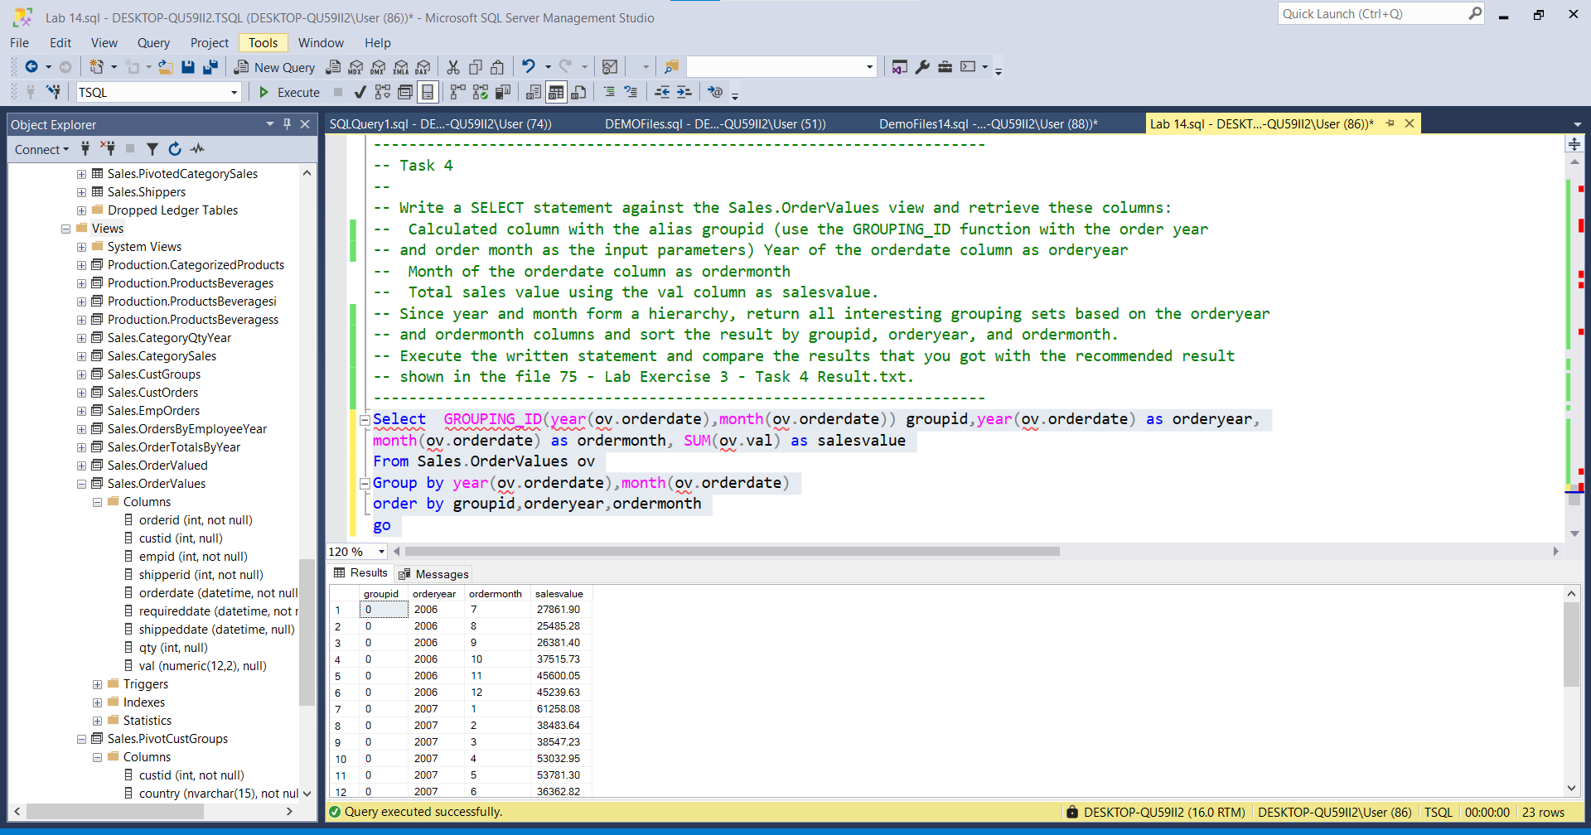

Rezultati :

Groupid |orderyear ordermonth salesvalue

-------------------------------------------------

0 2006 7 27861.90

0 2006 8 25485.28

0 2006 9 26381.40

0 2006 10 37515.73

0 2006 11 45600.05

0 2006 12 45239.63

0 2007 1 61258.08

0 2007 2 38483.64

0 2007 3 38547.23

0 2007 4 53032.95

0 2007 5 53781.30

0 2007 6 36362.82

0 2007 7 51020.86

0 2007 8 47287.68

0 2007 9 55629.27

0 2007 10 66749.23

0 2007 11 43533.80

0 2007 12 71398.44

0 2008 1 94222.12

0 2008 2 99415.29

0 2008 3 104854.18

0 2008 4 123798.70

0 2008 5 18333.64

---------------------------------------------------------------------

---------------------------------------------------------------------

--2--

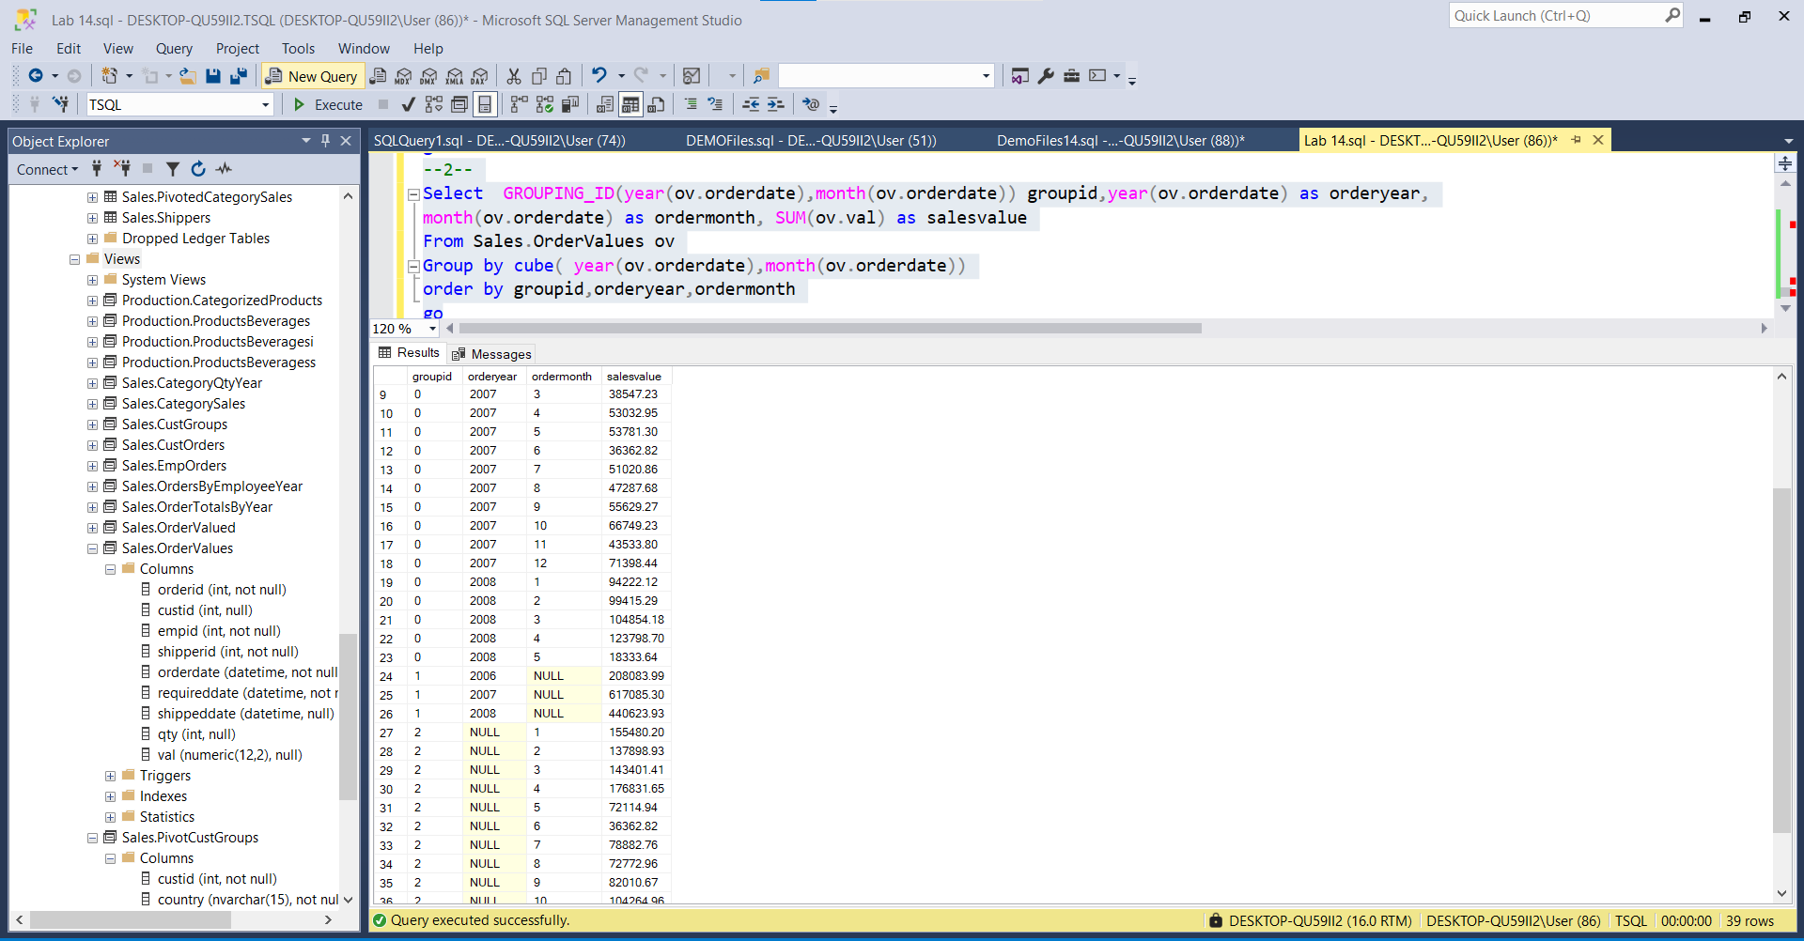

Result:

groupid orderyear ordermonth salesvalue

0 2006 7 27861.90

0 2006 8 25485.28

0 2006 9 26381.40

0 2006 10 37515.73

0 2006 11 45600.05

0 2006 12 45239.63

0 2007 1 61258.08

0 2007 2 38483.64

0 2007 3 38547.23

0 2007 4 53032.95

0 2007 5 53781.30

0 2007 6 36362.82

0 2007 7 51020.86

0 2007 8 47287.68

0 2007 9 55629.27

0 2007 10 66749.23

0 2007 11 43533.80

0 2007 12 71398.44

0 2008 1 94222.12

0 2008 2 99415.29

0 2008 3 104854.18

0 2008 4 123798.70

0 2008 5 18333.64

1 2006 NULL 208083.99

1 2007 NULL 617085.30

1 2008 NULL 440623.93

2 NULL 1 155480.20

2 NULL 2 137898.93

2 NULL 3 143401.41

2 NULL 4 176831.65

2 NULL 5 72114.94

2 NULL 6 36362.82

2 NULL 7 78882.76

2 NULL 8 72772.96

2 NULL 9 82010.67

2 NULL 10 104264.96

2 NULL 11 89133.85

2 NULL 12 116638.07

3 NULL NULL 1265793.22